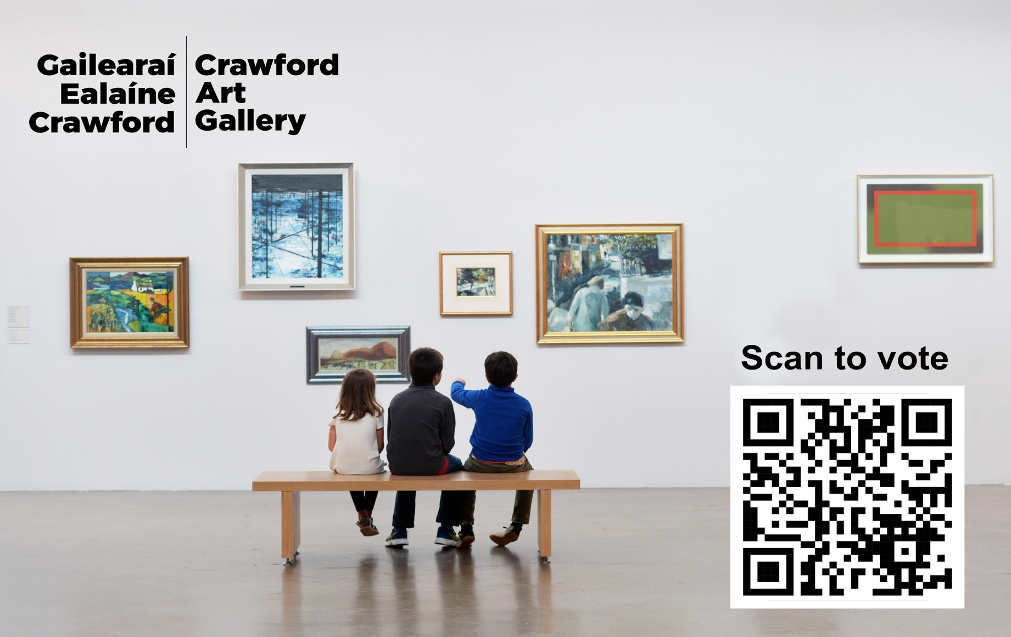

Art-lovers can select their favourite works for inclusion in a new exhibition at Crawford Art Gallery. Photo: Provision

Public asked to choose their best-loved artworks for Crawford Art Gallery exhibition

From old favourites to those new artworks that stop you in your tracks, Crawford Art Gallery is asking art lovers: If you could have a last chance to see one artwork from the collection, which would you choose?

You Tell We Show is a public vote running for two weeks in May, in which the public can select the artworks that mean the most to them, for inclusion in a summer exhibition.

Now You See It… is the name of the final exhibition of works from Crawford Art Gallery’s collection before the gallery’s two-year closure for redevelopment in autumn 2024.

Much-loved works like The Red Rose by John Lavery, Mary Swanzy’s Samoan Scene, Daniel Maclise’s The Falconer and Men of the South by Seán Keating have already been selected by curators for display in Now You See It… The public can add their own requests by scanning a QR code, which will direct them to an online form, and simply submitting their own personal choice.

There are over 3,000 works in Crawford Art Gallery’s collection, which forms a part of the publicly owned National Collection, so the artworks on display are only the tip of the iceberg when it comes to the treasured pieces that Crawford Art Gallery cares for, stores and conserves.

“We really want your help to celebrate the collection,” curator Dr Michael Waldron said.

“It’s the last chance to encounter Crawford Art Gallery’s collection on site in our storied building as we prepare to close for an ambitious redevelopment project, so we are using this exhibition to celebrate not only the artworks, but also the gallery-going public.”

“As curators, we are always aware of visitors who come back time and time again to be captivated by a particular work of art that holds meaning or power for them. An object that brings joy, strikes a chord, or feels significant. These moments truly bring the gallery to life and make our work so worthwhile.”

“So please let us know which artworks from the collection you will miss and would like to see again! We can’t wait to hear from you.”

The You Tell We Show vote is open for two weeks from Monday 13 May until Monday 27 May.

To take part, members of the public can scan the QR code displayed here or in the gallery, or for those who prefer a low-tech option, they can fill out a form at the welcome desk in the gallery.

Voters can also opt in to sharing the story of why they want a particular artwork included, and these stories may be included on labels next to the artworks in the exhibition. It might be a special memory or a particular anecdote.

For voters wishing to refresh their memory, The online collection of Crawford Art Gallery’s artworks is available to browse here:
www.crawfordartgallery.ie/online-collection/

After the voting period has closed, Crawford Art Gallery’s team will make a final selection of artworks based on popularity, suitability for display, and availability of the works.

Please note that certain artworks may not be available for display, including our collection of Harry Clarke’s stained glass, watercolours, and illustrations, as well as some examples of printmaking and digital film.

You Tell We Show public selection is live from Monday 13 May until Monday 27 May. Now You See It… will run from July until September 2024, exact dates to be confirmed.

ENDS

www.crawfordartgallery.ie Crawford Art Gallery, Emmet Place, Cork, Ireland.

Dyane Hanrahan Marketing & Communications Manager
E: dyanehanrahan@crawfordartgallery.ie T +353 (0) 21 4907856 M +353 (0) 86 8278151

Ellie O’Byrne Press Officer
E: press@crawfordartgallery.ie M +353 (0)87125 8446

Notes to Editor: for extra images please click here.

About Crawford Art Gallery

Crawford Art Gallery is an Irish National Cultural Institution (NCI) dedicated to contemporary and historic visual art, located in a significant heritage building in the heart of Cork city. Offering a dynamic programme of temporary exhibitions, it also houses a collection of national importance which tells the compelling story of Cork and Ireland over the last three centuries.

Originally built in 1724 as the city’s Customs House, the Gallery is home to the famous Canova Casts, gifted to Cork two centuries ago. Featured in the gallery’s collection of over 3,000 objects are contemporary artists Aideen Barry, Gerard Byrne, Maud Cotter, Dorothy Cross and Sean Scully as well as much-loved works by Irish artists James Barry, Harry Clarke, Mainie Jellett, Seán Keating, Daniel Maclise, Norah McGuinness and Jack B. Yeats.

About Crawford Art Gallery’s Capital Redevelopment 2024-2026

Crawford Art Gallery closes in Autumn 2024 for two years to undergo an enormously exciting capital redevelopment project.

This multi-million euro investment will increase gallery space by 45%, preserve and protect three centuries of existing built heritage, and create a cultural legacy for a new century as Cork continues to grow.

The project is a Government of Ireland 2040 project funded by the department of Tourism, Culture, Arts, Gaeltacht, Sport and Media in partnership with the Office of Public Works (OPW).

The award-winning Grafton Architects have worked on a redevelopment design that includes a new Learn and Explore facility for public engagement, significant storage for the National Collection at Crawford, a new entrance, and a dramatically improved public realm including new café facing onto Half Moon Street.

The building’s entrance will be reoriented to Emmet Place in line with the original Customs House layout dating to 1724.

A large new public gallery space will be created five stories above Cork City, creating a new vantage point for visitors to view city centre landmarks including Shandon and St Finbarre’s Cathedral.

Opening Hours

Open Daily
Monday–Saturday 10.00am–5.00pm Late opening Thursdays until 8.00pm Sundays and Bank Holidays Gallery: 11am - 4pm Entry Free

Tours
Free Tours Sundays and Bank Holiday Mondays 2pm Free Tours on Thursday 6.30 pm . This project is in support of the Night-Time Economy and funded by The Department of Tourism, Culture, Arts, Gaeltacht, Sport and Media.

Café: The Green Room
A classic old world dining room in Cork’s cultural epicentre that mixes traditional food offerings alongside contemporary trends.
Open 6 days a week with opening times on www.crawfordartgallery.ie

An pobal chun na saothair is fearr leo a roghnú do thaispeántas Ghailearaí Ealaíne Crawford

Más pictiúr é a chonaic tú fadó agus a d’fhan leat ó shin, nó saothar nua a chuaigh go mór i bhfeidhm ort, tá Gailearaí Ealaíne Crawford ag iarraidh ar an lucht spéise ealaíne: dá mbeadh an deis agat saothar ealaíne amháin ón mbailiúchán a fheiceáil den uair dheiridh, cé acu ceann a roghnófá?

Vóta poiblí is ea You Tell We Show a bheidh ar siúl ar feadh coicíse i mí Bealtaine agus a thabharfaidh deis don phobal na saothair ealaíne is mó a thaitníonn leo a roghnú le cur san áireamh i dtaispeántas an tsamhraidh.

Now You See It… an teideal atá ar an taispeántas deiridh de bhailiúchán Ghailearaí Ealaíne Crawford sula ndúnfar an gailearaí i bhfómhar 2024 d’athfhorbairt dhá bhliain.

Tá saothair mhóra ar nós The Red Rose le John Lavery, Samoan Scene le Mary Swanzy, The Falconer le Daniel Maclise agus Men of the South le Seán Keating roghnaithe cheana féin ag na coimeádaithe le cur ar taispeáint in Now You See It… Is féidir leis an bpobal a rogha féin a chur leis sin trí cód QR a scanadh a thabharfaidh chuig foirm ar líne iad agus is féidir leo a rogha phearsanta féin a chur san áireamh ansin.

Tá os cionn 3,000 saothar i mbailiúchán Ghailearaí Ealaíne Crawford, atá mar chuid den Bhailiúchán Náisiúnta atá i seilbh phoiblí, mar sin ní bhíonn ach cuid an-bheag de na saothair a choinníonn agus a chaomhnaíonn Gailearaí Ealaíne Crawford ar taispeáint.

“Tá bhur gcabhair uainn chun an bailiúchán a cheiliúradh,” a dúirt an coimeádaí an Dr Michael Waldron.

“Is é seo an deis deiridh taispeántas Ghailearaí Ealaíne Crawford a fheiceáil i bhfoirgneamh cáiliúil an ghailearaí sula ndúnfar é le tabhairt faoi thogra uaillmhianach athchóirithe, mar sin is deis atá sa taispeántas seo ceiliúradh a dhéanamh ní hamháin ar na saothair ach ar phobal an ghailearaí chomh maith.”

“Mar choimeádaithe, tugaimid faoi deara i gcónaí nuair a thagann cuairteoirí ar ais arís agus arís eile le breathnú ar shaothar faoi leith a chuaigh go mór i bhfeidhm orthu. Bíonn rud mar sin taitneamhach, mothúchánach nó tábhachtach. Is taithí mar sin a chuireann beocht sa ghailearaí agus a chuireann fiúntas lenár gcuid oibre.”

“Le bhur dtoil, mar sin, abair linn cé hiad na saothair ón mbailiúchán a aireoidh sibh uaibh agus a bhfuil fonn oraibh iad a fheiceáil arís! Is fada linn bhur dtuairimí a chloisteáil.”
Beidh vóta You Tell We Show oscailte ar feadh coicíse ón Luan an 13 Bealtaine go dtí an Luan an 27 Bealtaine.

Le páirt a ghlacadh ann, is féidir le baill den phobal an QR atá anseo nó ar taispeáint sa ghailearaí a scanadh, nó dóibh siúd arbh fhearr leo an rogha thraidisiúnta, is féidir foirm a líonadh ag deasc fáiltithe an ghailearaí.

Beidh an deis ag na vótálaithe scéalta a roinnt freisin maidir leis an bhfáth ar mhaith leo saothar faoi leith a chur sa taispeántas, agus d’fhéadfadh sé go mbeadh na scéalta sin le feiceáil ar lipéid le taobh na saothar sa taispeántas. B’fhéidir gur cuimhne speisialta a bheidh ann, nó scéilín beag pearsanta.

Le cur i gcuimhne duit féin cé na saothair atá sa bhailiúchán, is féidir bailiúchán ar líne Ghailearaí Ealaíne Crawford a fheiceáil anseo:
www.crawfordartgallery.ie/online-collection/

Nuair a bheidh an vótáil déanta, déanfaidh foireann Ghailearaí Ealaíne Crawford an cinneadh deiridh ar na saothair, ag brath ar mhianta an phobail, ar oiriúnacht do thaispeántas agus ar na saothair a bheith ar fáil.

Tabhair faoi deara go bhféadfadh sé nach mbeidh saothair ealaíne faoi leith ar fáil le taispeáint, lena n-áirítear an bailiúchán gloine daite, pictiúr uiscedhatha agus léaráidí le Harry Clarke chomh maith le samplaí de dhéantús priontaí agus físeáin dhigiteacha.

Beidh an rogha phoiblí You Tell We Show beo ón Luan 13 Bealtaine go dtí an Luan 27 Bealtaine. Beidh Now You See It… oscailte idir mí Iúil agus mí Mheán Fómhair 2024, dátaí le deimhniú.

CRÍOCH

www.crawfordartgallery.ie Gailearaí Ealaíne Crawford, Plás Emmet, Corcaigh, Éire.

Dyane Hanrahan Bainisteoir Margaíochta & Cumarsáide
R: dyanehanrahan@crawfordartgallery.ie T +353 (0) 21 4907856 M +353 (0) 86 8278151

Ellie O’Byrne Preasoifigeach
R: press@crawfordartgallery.ie M +353 (0)87125 8446

Nótaí don Eagarthóir: chun breis íomhánna a fheiceáil, cliceáil anseo.

Maidir le Gailearaí Ealaíne Crawford

Is institiúid chultúrtha náisiúnta é Gailearaí Ealaíne Crawford atá suite i bhfoirgneamh oidhreachta suntasach i gcroílár chathair Chorcaí agus atá tiomnaithe do na hamharc-ealaíona, go stairiúil agus go comhaimseartha araon. Agus é ag cur clár fuinniúil taispeántas sealadach ar fáil, tá bailiúchán náisiúnta tábhachtach faoina dhíon freisin a insíonn scéal spéisiúil Chorcaí agus na hÉireann le trí chéad bliain anuas.

Tógadh ar dtús i 1724 é mar Theach Custaim na cathrach agus tá na Múnlaí Canova cáiliúla ar taispeáint sa Ghailearaí, a bronnadh ar Chorcaigh dhá chéad bliain ó shin. Tá os cionn 3,000 saothar i mbailiúchán an ghailearaí. Ina measc tá na healaíontóirí comhaimseartha Aideen Barry, Gerard Byrne, Maud Cotter, Dorothy Cross agus Seán Scully mar aon le saothair a bhfuil gean mór orthu leis na healaíontóirí Éireannacha James Barry, Harry Clarke, Mainie Jellett, Seán Keating, Daniel Maclise, Norah McGuinness agus Jack B. Yeats.

Maidir le hAthfhorbairt Chaipitil Ghailearaí Ealaíne Crawford 2024-2026

Beidh Gailearaí Ealaíne Crawford dúnta i bhfómhar 2024 ar feadh dhá bhliain chun tabhairt faoi thogra athfhorbartha caipitil.

Cuirfidh an infheistíocht, ar fiú na milliúin euro é, 45% breise le spás an ghailearaí, agus déanfaidh sé trí chéad bliain d’oidhreacht thógtha a chaomhnú agus a chosaint, agus cruthófar oidhreacht chultúrtha don ghlúin amach romhainn de réir mar a bheidh Corcaigh ag leanúint ag fás.

Is togra de chuid Thograí Rialtas na hÉireann 2040 é atá ag fáil maoiniú ón Roinn Turasóireachta, Cultúir, Ealaíon, Gaeltachta, Spóirt agus Meáin i gcomhar le hOifig na nOibreacha Poiblí (OPW).

Tá Grafton Architects a bhfuil gradaim bainte acu tar éis obair a dhéanamh ar dhearadh athfhorbartha lena n-áirítear áis Foghlam agus Fiosraithe nua le rannpháirtíocht ghníomhach, stóráil shuntasach don Bhailiúchán Náisiúnta i nGailearaí Crawford, bealach isteach nua, agus spás poiblí a bheidh feabhsaithe go mór lena n-áirítear caifé nua ar Shráid na Leathghealaí.

Beidh bealach isteach an fhoirgnimh curtha ar ais go Plás Emmet de réir leagan amach Theach an Chustaim a chuaigh siar go 1724.

Cruthófar spás gailearaí mór nua le cúig urlár ag féachaint amach ar Chathair Chorcaí, a chruthaíonn radharc do chuairteoirí chun féachaint ar shainchomharthaí i lár na cathrach lena n-áirítear An Seandún agus Ardeaglais Naomh Fionnbarra.

Uaireanta Oscailte

Oscailte go Laethúil
Dé Luain-Dé Sathairn 10.00am–5.00pm Oscailte go déanach Déardaoin go dtí 8.00pm Dé Domhnaigh agus Laethanta Saoire Bainc: 11am - 4pm
Cead isteach Saor in aisce

Turais
Turais Saor in aisce Dé Domhnaigh agus Luain Saoire Bainc 2pm Turais Saor in aisce Déardaoin 6.30pm. Tacaíonn an tionscadal seo le Geilleagar san Oíche agus faigheann sé tacaíocht ón Roinn Turasóireachta, Cultúir, Ealaíon, Gaeltachta, Spóirt agus Meáin.

Caifé: The Green Room

Seomra bia clasaiceach ón seansaol i gcroí cultúrtha Chorcaí a mheascann earraí traidisiúnta bia le taobh treochtaí comhaimseartha. Oscailte 6 lá na seachtaine agus tá na huaireanta oscailte ar www.crawfordartgallery.ie

