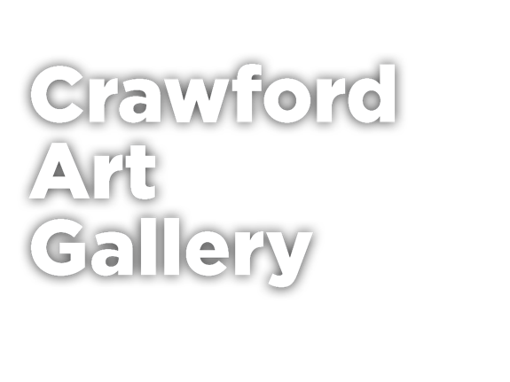
A group of visitors being guided through Saturation: the everyday transformed at Crawford Art Gallery
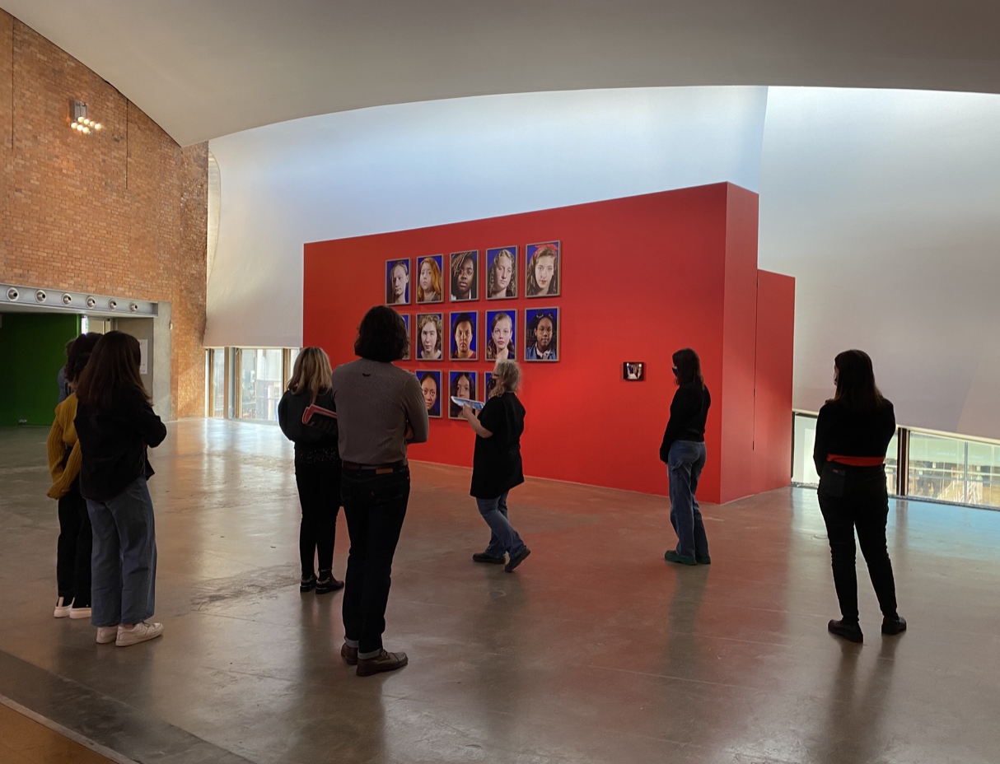

Press Release 16/02/22
Crawford Art Gallery announces tours to be held every Sunday and Bank Holiday Monday .
Crawford Art Gallery will provide tours which are open to all and free of charge every Sunday and Bank Holiday Monday, starting from Sunday 20 February at 2pm.
Expert tour guides invite visitors to delve into the National Collection and numerous exhibitions held at Crawford Art Gallery. The tour experience will vary from week to week, offering fascinating insights, information and the stories behind the artworks and the artists who created them. Spaces on the tours will be available on a first-come, first-served basis with no pre-booking necessary.
“It is fantastic to see tours coming back to the Gallery, we are so excited to see first-time visitors and other visitors coming back again and again to enjoy our tours with experienced art historians and artists. Tours are a great introduction to the Gallery and will suit everyone, from families and young people, to the more seasoned visitor. You don’t have to have experience of art to enjoy the tours; we encourage people to just give it a try,” says Marketing and Communications Manager, Dyane Hanrahan.
To celebrate St Patrick’s Festival the Gallery will offer tours on Thursday 17, Friday 18 and Sunday 20 March at 2:00pm.

Originally built in 1724 as the city’s Customs House, the Gallery is home to the famous Canova Casts, gifted to Cork two centuries ago. Featured in the Gallery’s collection of over 3,000 objects are well-known and much-loved works by Irish artists James Barry, Harry Clarke, Mainie Jellett, Seán Keating, Daniel Maclise, Norah McGuinness, Edith Somerville, and Jack B. Yeats, as well as contemporary artists Aideen Barry, Gerard Byrne, Maud Cotter, Dorothy Cross, Brian Maguire, Eilis O’Connell, and Hughie O’Donoghue.
Crawford Art Gallery is an Irish national cultural institution, dedicated to contemporary and historic visual art. Home to a collection of national importance, it tells a compelling story of Cork and Ireland over the last three centuries, while also offering a vibrant and dynamic programme of temporary exhibitions. An oasis of calm and tranquillity, Crawford Art Gallery is open seven days a week, tours are free of charge and no booking is required.

END

Dyane Hanrahan
Marketing & Communications Manager
E dyanehanrahan@crawfordartgallery.ie
T +353 (0) 21 4907856
M +353 (0) 86 8278151
W www.crawfordartgallery.ie
Crawford Art Gallery,
Emmet Place,
Cork, Ireland.

T12 TNE6

Opening Hours
Monday–Saturday 10.00am–5.00pm
Late opening Thursdays until 8.00pm
Sundays and Bank Holidays Gallery: 11am - 4pm

Upcoming Exhibitions
The Port of Cork Collection
26 February – 28 August 2022
BOTANICA: The Art of Plants

17 March – 18 September 2022
Zurich Portrait Prize 2021 & Zurich Young Portrait Prize 2021
23 April – 17 July 2022

Crawford Gallery Café & Garden Café
The Gallery boasts an award-winning Café in stunning surroundings, serving fresh local produce for which Cork is famous. For opening hours www.crawfordgallerycafe.com
