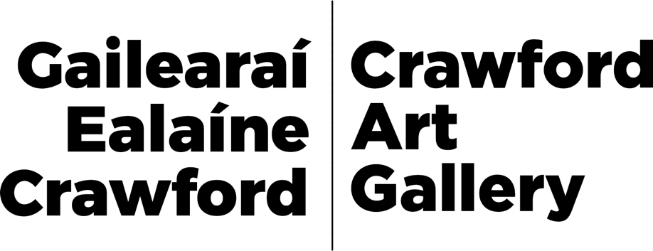
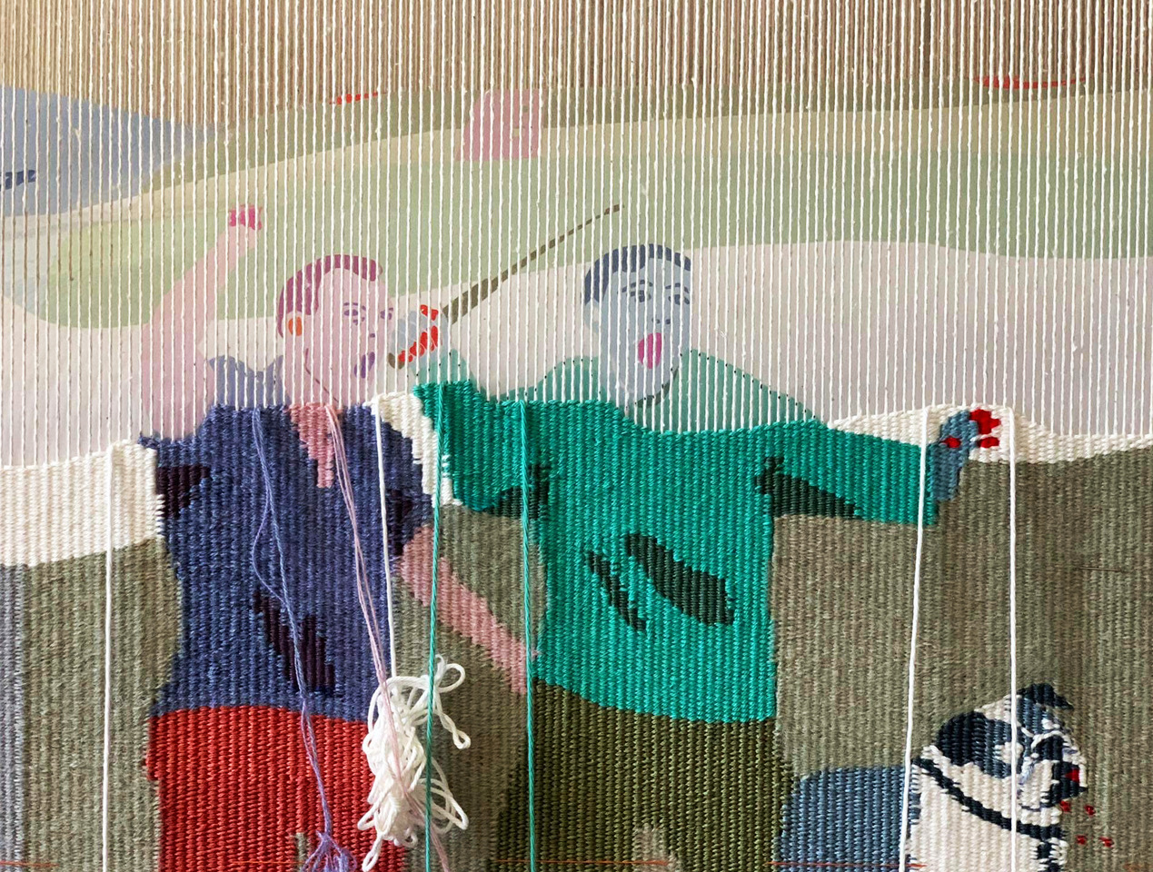
Ursula Burke, These Fragile Monuments, 2024. © the artist.

Irish artist and Ukrainian weaver collaborate on guerrilla warfare themed tapestry

Shared histories of oppression between Ireland and Ukraine are highlighted in Ursula Burke’s These Fragile Monuments at Crawford Art Gallery, in which the artist collaborates with Ukrainian weaver Zhanna Petrenko.

Burke’s tapestry frieze investigates Irish historical, art historical and contemporary representations of guerrilla warfare as part of the Cork gallery’s Decade of Centenaries programme, Building as Witness.

She has invited Kyiv-based Petrenko to weave the tapestry, creating a thread between two countries and periods of time – Ireland and Ukraine, both historically oppressed by more powerful neighbours, and both having experienced the devastating effects of famine.

The tapestry is inspired by the work of Norwegian artist Hannah Ryggen (1894-1970) who made a series of powerful tapestries representing images of resistance and highlighting the brutality of Nazi occupied Norway during the Second World War.
Burke, whose practice incorporates porcelain sculpture, soft sculpture, embroidery sculpture and drawing, has also created a battle-bruised dog modelled on The Jennings Dog – a Greek bronze from the 2nd century CE – which is covered in hand-embroidered flames, emblematic of all the Irish houses and commercial premises burnt out by the infamous Black and Tans.

Ursula Burke’s These Fragile Monuments is one of six Building as Witness artist projects commissioned by Crawford Art Gallery and supported by the Department of Tourism, Culture, Arts, Gaeltacht, Sport and Media under the Decade of Centenaries Programme 2012 - 2023.

“In conversation” event

Ursula Burke will appear in conversation with Dr Edwin Coomasaru, a historian of modern and contemporary British, Irish and Sri Lankan art, at 6pm on Friday 24 May in the Lecture Theatre of Crawford Art Gallery.

The exhibition of URSULA BURKE: These Fragile Monuments runs from Saturday 25 May until Sunday 21 July in the Sculpture Galleries at Crawford Art Gallery.

ENDS

www.crawfordartgallery.ie Crawford Art Gallery, Emmet Place, Cork, Ireland.

Dyane Hanrahan Marketing & Communications Manager
E: dyanehanrahan@crawfordartgallery.ie T +353 (0) 21 4907856 M +353 (0) 86 8278151

Ellie O’Byrne Press Officer
E: press@crawfordartgallery.ie M +353 (0)87125 8446

Notes for editors: for extra images please click here.

Ursula Burke is an Irish artist whose practice incorporates Porcelain Sculpture, Soft Sculpture, Embroidery Sculpture and Drawing. Burke's work explores precarity in the social realm, power relations in the political arena and post-conflict histories relative to Northern Ireland. Her work creates a conceptual bridge between antiquity and the contemporary, mining art historical tropes of representation and display.

Mediated through craft-based processes re-configured in a fine art context, her approach destabilises conventions around traditional approaches to making by

using unexpected juxtapositions of materials, processes and images with a desire that bends towards the surreal.
Zhanna Petrenko was born in 1995 in Ukraine, where she still lives and works. She is a graduate of the Lviv National Academy of Arts. She was awarded the Grand Prix at the Second International Symposium of Artistic Textiles "Teacher and Student" in Lviv. She has shown her works at exhibitions in the Ukraine and at the exhibition of the Cordis Prize 2021.
In her practice, Petrenko follows the principle of collage by tearing, reassembling, editing, rearranging, redefining and covering materials. The resulting delicate compositions combine glimpses of technology, speculative imagery and
philosophy. Petrenko also experiments with information carriers such as photographic film or magnetic tape. She is interested in collective memory and identity, the development of social media and the idea of information noise.

Dr Edwin Coomasaru is a historian of modern and contemporary British, Irish and Sri Lankan art; his research considers the politics of ‘gender, sexuality, and race.’ Coomasaru is an editor of the journal Visual Culture in Britain.

About Crawford Art Gallery

Crawford Art Gallery is an Irish National Cultural Institution (NCI) dedicated to contemporary and historic visual art, located in a significant heritage building in the heart of Cork city. Offering a dynamic programme of temporary exhibitions, it also houses a collection of national importance which tells the compelling story of Cork and Ireland over the last three centuries.

Originally built in 1724 as the city’s Customs House, the Gallery is home to the famous Canova Casts, gifted to Cork two centuries ago. Featured in the gallery’s collection of over 3,000 objects are contemporary artists Aideen Barry, Gerard Byrne, Maud Cotter, Dorothy Cross and Sean Scully as well as much-loved works by Irish artists James Barry, Harry Clarke, Mainie Jellett, Seán Keating, Daniel Maclise, Norah McGuinness and Jack B. Yeats.

About Crawford Art Gallery’s Capital Redevelopment 2024-2026

Crawford Art Gallery closes in Autumn 2024 for two years to undergo an enormously exciting capital redevelopment project.

This multi-million euro investment will increase gallery space by 45%, preserve and protect three centuries of existing built heritage, and create a cultural legacy for a new century as Cork continues to grow.

The project is a Government of Ireland 2040 project funded by the department of Tourism, Culture, Arts, Gaeltacht, Sport and Media in partnership with the Office of Public Works (OPW).

The award-winning Grafton Architects have worked on a redevelopment design that includes a new Learn and Explore facility for public engagement, significant

storage for the National Collection at Crawford, a new entrance, and a dramatically improved public realm including new café facing onto Half Moon Street.

The building’s entrance will be reoriented to Emmet Place in line with the original Customs House layout dating to 1724.

A large new public gallery space will be created five stories above Cork City, creating a new vantage point for visitors to view city centre landmarks including Shandon and St Finbarre’s Cathedral.

Opening Hours
Monday–Saturday 10.00am–5.00pm Late opening Thursdays until 8.00pm Sundays and Bank Holidays Gallery: 11am - 4pm Entry Free

Tours
Free Tours Sundays and Bank Holiday Mondays 2pm Free Tours on Thursday 6.30 pm . This project is in support of the Night-Time Economy and funded by The Department of Tourism, Culture, Arts, Gaeltacht, Sport and Media.

Café: The Green Room
A classic old world dining room in Cork’s cultural epicentre that mixes traditional food offerings alongside contemporary trends.
Open 6 days a week with opening times on www.crawfordartgallery.ie

Comhoibríonn ealaíontóir Éireannach agus fíodóir na hÚcráine ar thaipéis le téama treallchogaíochta

Dírítear ar an ansmacht a bhí coitianta go stairiúil in Éirinn agus san Úcráin in These Fragile Monuments le hUrsula Burke i nGailearaí Ealaíne Crawford, ina gcomhoibríonn an t-ealaíontóir le fíodóir de chuid na hÚcráine Zhanna Petrenko.

Fiosraíonn fríos taipéise de chuid Burke léirithe ó stair na hÉireann, ó stair na healaíne agus léirithe comhaimseartha treallchogaíochta mar chuid de chlár Dheich mBliana na gCuimhneachán Building as Witness sa ghailearaí i gCorcaigh.

Thug sí cuireadh do Petrenko atá lonnaithe sa Chív an taipéis a fhí, chun snáithe a chruthú idir dhá thír agus dhá thréimhse ama - Éire agus an Úcráin, dhá thír a bhí faoi smacht go stairiúil ag na tíortha cumhachtacha comharsanachta, agus a d’fhulaing tionchair uafásacha an ghorta.

Faigheann an taipéis spreagadh ó shaothar an ealaíontóra Ioruaigh Hannah Ryggen (1894-1970) a rinne sraith taipéisí cumhachtacha a léiríonn íomhánna

frithbheartaíochta agus a leagann béim ar an mbrúidiúlacht a bhain leis an Iorua a bhí faoi sheilbh na Naitsithe le linn an Dara Cogadh Domhanda.

Cuimsíonn cleachtas Ursula Burke dealbha poirceallánacha, dealbha boga, dealbha bróidnéireachta agus líníochta gus tá dealbh cruthaithe aici freisin múnlaithe ar mhadra traochadh catha The Jennings Dog - dealbh chré-umha Gréagach ón 2a haois CE - atá clúdaithe le lasracha bróidnithe lámhdhéanta de na tithe agus de na háitribh tráchtála go léir a dhóigh na Dúchrónaigh cáiliúla.

Tá These Fragile Monuments le hUrsula Burke ar cheann de shé thogra ealaíne Building as Witness atá coimisiúnaithe ag Gailearaí Ealaíne Crawford a fhaigheann maoiniú ón Roinn Turasóireachta, Cultúir, Ealaíon, Gaeltachta, Spóirt agus Meán faoi Chlár Dheich mBliana na gCuimhneachán 2012 - 2023.

Imeacht “In Conversation”

Beidh Ursula Burke i gcomhrá leis an Dr Edwin Coomasaru, staraí ar ealaín nua-aoiseach agus chomhaimseartha na Breataine, na hÉireann agus Shrí Lanca, ar 6pm Dé hAoine 24 Bealtaine i dTéatar na Léachta i nGailearaí Ealaíne Crawford.

URSULA BURKE:These Fragile Monuments ar taispeáint ón Satharn 25 Bealtaine go dtí an Domhnach 21 Iúil sna Gailearaithe Dealbhóireachta i nGailearaí Ealaíne Crawford.

Nótaí le haghaidh eagarthóirí:

Is ealaíontóir Éireannach í Ursula Burke agus cuimsíonn a cleachtas Dealbha Poirceallánacha, Dealbha Boga, Dealbha Bróidnéireachta agus Líníocht. Fiosraíonn saothar Burke neamhchinnteacht i réimse na sochaí, gaol stádais sa réimse polaitiúil agus an stair i ndiaidh coinbhleachta a bhaineann le Tuaisceart Éireann. Cruthaíonn a cuid oibre droichead coincheapúil idir an tseandacht agus an aimsir seo, ag tarraingt ar thróip stairiúla ealaíne a bhaineann le léiriú agus taispeáint.

Tagann sí ar réiteach trí phróisis atá bunaithe ar cheardaíocht atá leagtha amach sa chomhthéacs mínealaíne. Cuireann a cur chuige coinbhinsiúin trína chéile maidir le cur chuigí traidisiúnta déantúsaíochta trí úsáid a bhaint as ábhair, as próisis agus as íomhánna neamhghnáthacha le hais rudaí eile agus mian aici a chromann i dtreo taithí osréalach.

Is staraí ar ealaín nua-aoiseach agus chomhaimseartha na Breataine, na hÉireann agus Shrí Lanca é an Dr Edwin Coomasaru; déanann trína chuid taighde cúrsaí polaitíochta a mheas maidir le ‘hinscne, gnéasacht, agus cine’. Is eagarthóir é Coomasaru ar an irisleabhar Visual Culturesa Bhreatain.

CRÍOCH

www.crawfordartgallery.ie Gailearaí Ealaíne Crawford, Plás Emmet, Corcaigh, Éire.

Dyane Hanrahan Bainisteoir Margaíochta & Cumarsáide

R: dyanehanrahan@crawfordartgallery.ie T +353 (0) 21 4907856 M +353 (0) 86 8278151

Ellie O’Byrne Preasoifigeach
R: press@crawfordartgallery.ie M +353 (0)87125 8446

Nótaí don Eagarthóir: chun breis íomhánna a fheiceáil, cliceáil anseo.

Maidir le Gailearaí Ealaíne Crawford

Is institiúid chultúrtha náisiúnta é Gailearaí Ealaíne Crawford atá suite i bhfoirgneamh oidhreachta suntasach i gcroílár chathair Chorcaí agus atá
tiomnaithe do na hamharc-ealaíona, go stairiúil agus go comhaimseartha araon. Agus é ag cur clár fuinniúil taispeántas sealadach ar fáil, tá bailiúchán náisiúnta tábhachtach faoina dhíon freisin a insíonn scéal spéisiúil Chorcaí agus na hÉireann le trí chéad bliain anuas.

Tógadh ar dtús i 1724 é mar Theach Custaim na cathrach agus tá na Múnlaí Canova cáiliúla ar taispeáint sa Ghailearaí, a bronnadh ar Chorcaigh dhá chéad bliain ó shin. Tá os cionn 3,000 saothar i mbailiúchán an ghailearaí. Ina measc tá na healaíontóirí comhaimseartha Aideen Barry, Gerard Byrne, Maud Cotter, Dorothy Cross agus Seán Scully mar aon le saothair a bhfuil gean mór orthu leis na healaíontóirí Éireannacha James Barry, Harry Clarke, Mainie Jellett, Seán Keating, Daniel Maclise, Norah McGuinness agus Jack B. Yeats.

Maidir le hAthfhorbairt Chaipitil Ghailearaí Ealaíne Crawford 2024-2026

Beidh Gailearaí Ealaíne Crawford dúnta i bhfómhar 2024 ar feadh dhá bhliain chun tabhairt faoi thogra athfhorbartha caipitil.

Cuirfidh an infheistíocht, ar fiú na milliúin euro é, 45% breise le spás an ghailearaí, agus déanfaidh sé trí chéad bliain d’oidhreacht thógtha a chaomhnú agus a chosaint, agus cruthófar oidhreacht chultúrtha don ghlúin amach romhainn de réir mar a bheidh Corcaigh ag leanúint ag fás.

Is togra de chuid Thograí Rialtas na hÉireann 2040 é atá ag fáil maoiniú ón Roinn Turasóireachta, Cultúir, Ealaíon, Gaeltachta, Spóirt agus Meáin i gcomhar le hOifig na nOibreacha Poiblí (OPW).

Tá Grafton Architects a bhfuil gradaim bainte acu tar éis obair a dhéanamh ar dhearadh athfhorbartha lena n-áirítear áis Foghlam agus Fiosraithe nua le rannpháirtíocht ghníomhach, stóráil shuntasach don Bhailiúchán Náisiúnta i nGailearaí Crawford, bealach isteach nua, agus spás poiblí a bheidh feabhsaithe go mór lena n-áirítear caifé nua ar Shráid na Leathghealaí.

Beidh bealach isteach an fhoirgnimh curtha ar ais go Plás Emmet de réir leagan amach Theach an Chustaim a chuaigh siar go 1724.

Cruthófar spás gailearaí mór nua le cúig urlár ag féachaint amach ar Chathair Chorcaí, a chruthaíonn radharc do chuairteoirí chun féachaint ar

shainchomharthaí i lár na cathrach lena n-áirítear An Seandún agus Ardeaglais Naomh Fionnbarra.

Uaireanta Oscailte
Dé Luain-Dé Sathairn 10.00am–5.00pm Oscailte go déanach Déardaoin go dtí 8.00pm Dé Domhnaigh agus Laethanta Saoire Bainc: 11am - 4pm
Cead isteach Saor in aisce

Turais
Turais Saor in aisce Dé Domhnaigh agus Luain Saoire Bainc 2pm Turais Saor in aisce Déardaoin 6.30pm. Tacaíonn an tionscadal seo le Geilleagar san Oíche agus faigheann sé tacaíocht ón Roinn Turasóireachta, Cultúir, Ealaíon, Gaeltachta, Spóirt agus Meáin.

Caifé: The Green Room
Seomra bia clasaiceach ón seansaol i gcroí cultúrtha Chorcaí a mheascann earraí traidisiúnta bia le taobh treochtaí comhaimseartha. Oscailte 6 lá na seachtaine agus tá na huaireanta oscailte ar www.crawfordartgallery.ie

