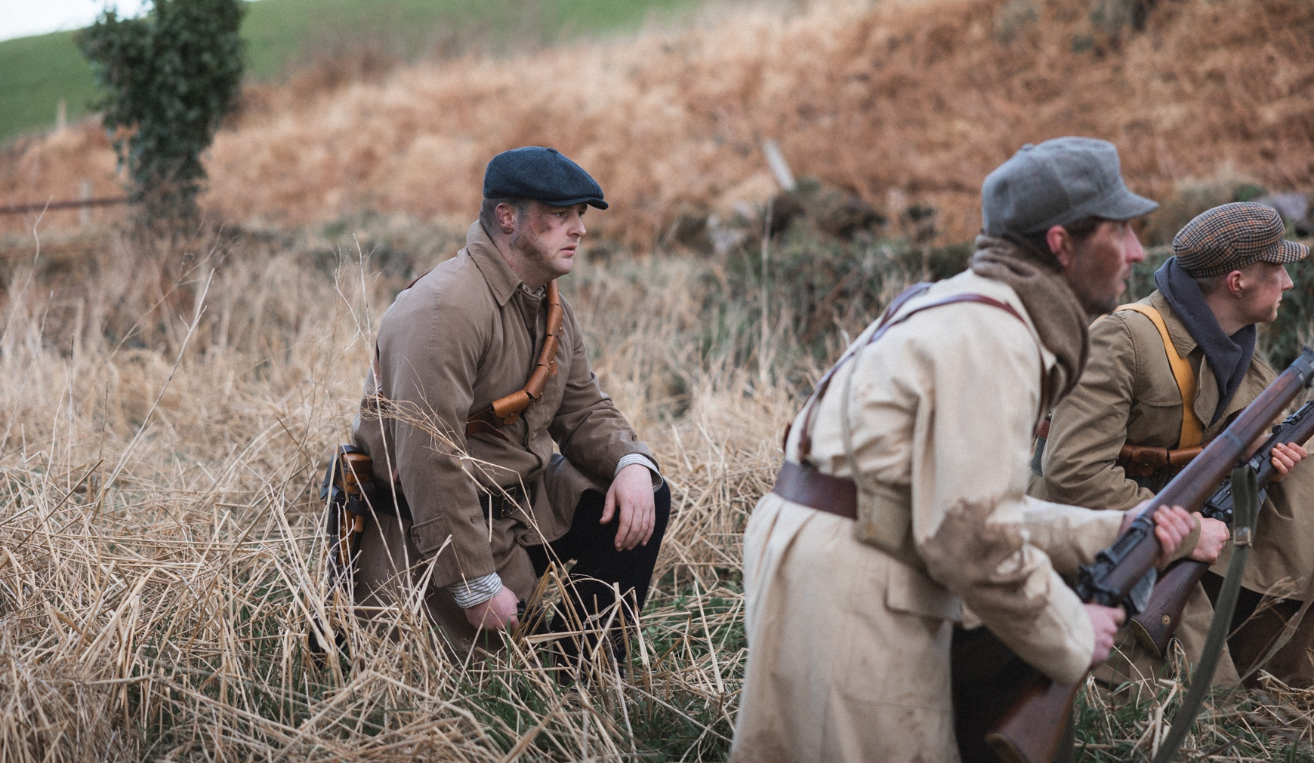

On set in Skibbereen filming Sit Stand Smoke and bringing Seán Keating’s Men of the South to life: L-R, Adam Duggan, Al Draper, Danny Horgan. Photo Credit: Tadhg Richardson

Renowned Irish painter Seán Keating’s unique personality shines through in new immersive Virtual Reality film

The unique personality of renowned painter Seán Keating is eerily present in a new Virtual Reality art experience, Sit Stand Smoke, which opens at the Crawford Art Gallery in Cork on Friday 26 April.

Sit Stand Smoke explores the motivation and circumstances behind the creation of one of Keating’s best known works: Men of the South (1921-22).
Viewers can don a VR headset in the gallery and immerse themselves in unique insights into the world of the painting.
Sit Stand Smoke takes us into the unexpected world of Dr. Éimear O’Connor, art historian, Seán Keating’s biographer, and in this narrative, a newly initiated Virtual Reality director casting actors for her first VR project.

Although full of challenges, Virtual Reality does afford Éimear the opportunity to have a conversation with the artist, played by his great-grandson, Jonathan Quinlan.
CURTIN // KEATING (co-artists Linda Curtin and David Keating - the latter being the grandson of the painter) co-created Sit Stand Smoke as part of Crawford Art Gallery’s Building as Witness series of Decade of Centenaries commissions.
Two artists working at the intersection of their overlapping practices, CURTIN// KEATING are fascinated by the process of making co-authored work in virtual reality.

Curtin’s background is as a visual artist and filmmaker working in immersive art. Her projects include Everything Alive Is In Movement and The Magic of Cinema. Keating is a film director and screenwriter - best known for his feature films Wake Wood, Last of the High Kings and as a writer on Into The West.

The prototype for Sit Stand Smoke was funded by Screen Ireland / Animation Ireland Innovation & Immersive Development Fund, BT Business and Ballymore and was supported by the Cork Film Centre and Immersive Ireland.
Sit Stand Smoke runs at Crawford Art Gallery from 26 April – 5 May 2024. For more visit www.crawfordartgallery.ie.

ENDS
For a full folder of hi-res images, click here.
For more on the Building as Witness projects, click here.

For interviews with CURTIN//KEATING or Dr Eimear O’Connor, please contact:

Ellie O’Byrne Press Officer
email: press@crawfordartgallery.ie Tel: +353 (0)87125 8446

Dyane Hanrahan Marketing & Communications Manager E: dyanehanrahan@crawfordartgallery.ie T +353 (0) 21 4907856 M +353 (0) 86 8278151

More about Crawford Art Gallery:
Crawford Art Gallery is an Irish National Cultural Institution, dedicated to contemporary and historic visual art, located in a significant heritage building in the heart of Cork city. Offering a vibrant and dynamic programme of temporary exhibitions, it is also houses a collection of national importance which tells a compelling story of Cork and Ireland over the last three centuries.

Originally built in 1724 as the city’s Customs House, the Gallery is home to the famous Canova Casts, gifted to Cork two centuries ago. Featured in the gallery’s collection of over 3,000 objects are contemporary artists Aideen Barry, Gerard Byrne, Maud Cotter, Dorothy Cross, Tacita Dean, and Sean Scully as well as much-loved works by Irish artists James Barry, Harry Clarke, Mainie Jellett, Seán Keating, Daniel Maclise, Norah McGuinness, Edith Somerville, and Jack B. Yeats.

An oasis of calm and tranquility, Crawford Art Gallery is open seven days a week, free to enter, and a must-see for locals and tourists alike.

Opening Hours
Monday–Saturday 10.00am–5.00pm Late opening Thursdays until 8.00pm Sundays and Bank Holidays Gallery: 11am - 4pm Entry Free

Tours
Free Tours Sundays and Bank Holiday Mondays 2pm Free Tours on Thursday 6.30 pm . This project is in support of the Night-Time Economy and funded by The Department of Tourism, Culture, Arts, Gaeltacht, Sport and Media.

Café: The Green Room
A classic old world dining room in Cork’s cultural epicentre that mixes traditional food offerings alongside contemporary trends.
Opening times on www.crawfordartgallery.ie

Leagan Gaeilge:

“Pearsantacht agus paisin” an ealaíontóra cháiliúil Éireannaigh Seán Keating ag lonrú tríd a scannán nua tumthach um Réaltacht Fhíorúil

Beidh scannán um réaltacht fhíorúil a chuireann beocht i bpéinteáil iomráiteach de chuid Seán Keating Men of the South ar oscailt don phobal i nGailearaí Ealaíne Crawford i gCorcaigh an 26 Aibreán.

Is féidir leis an lucht féachana na cluasáin um réaltacht fhíorúil a chur orthu féin agus a bheith sáite i Sit Stand Smoke, domhan tumthach a chuireann beocht i Men of the South agus a thugann léargais iontacha dúinn ar phearsantacht, ar phaisin agus ar shainspéiseanna Sheáin Keating féin, i gcomhluadar an staraí ealaíontóra Dr Éimear O’Connor.

Glacann aisteoirí páirt i bpríomhróil a léirítear i Men of the South agus glacann an t-ealaíontóir féin ról caimeo sa scannán; is minic a thugtar traidisiúnaí ar Sheán Keating a bhíonn fiosrach gan choinne faoin teicneolaíocht nua um réaltacht fhíorúil atá ar taispeáint.

Léiríonn Men of the South (1921-22) colún reatha de Bhriogáid Chorcaí Uimhir 2 ar feitheamh le luíochán a dhéanamh le linn Chogadh na Saoirse. Bhí an phéinteáil buanaithe i gcuimhne mar stampa in 2020 agus bhí sé mar íomhá ar chlúdach Atlas of the Irish Revolution, a d’fhoilsigh Cork University Press, in 2017.

Tá an taithí um réaltacht fhíorúil ag ceiliúradh céad bliain ón mí ó ceannaíodh Men of the South do bhailiúchán Ghailearaí Ealaíne Crawford: chomhaontaigh an Coiste Tiomnachta Gibson an phéinteáil a cheannach an 17 Aibreán 1924.

Chomhchruthaigh na déantóirí scannán Linda Curtin agus David Keating Sit Stand Smoke mar chuid de shraith Ghailearaí Ealaíne Crawford Building as Witness de choimisiúin Dheich mBliana na gCuimhneachán.

Is ealaíontóir agus déantóir scannán í Linda Curtin lena bhfuil Growhouse mar chuid dá saothair, suiteáil scannán ar gháinneáil ar dhaoine d’Fhéile Lár an tsamhraidh Chorcaí, agus Hill of Friday, togra ealaíon rannpháirtíoch ó ghlúin go glúin i gCnoc na hAoine, Corcaigh.

Is é David Keating an comhstiúrthóir, ar a bhfuil aithne is fearr ar a shaothar ó na scannáin Into The West agus The Last of the High Kings, atá mar gharmhac Seán Keating.

Beidh Sit Stand Smoke ar siúl i nGailearaí Ealaíne Crawford ón 26 Aibreán – 5 Bealtaine 2024.

CRÍOCH

Nótaí don Eagarthóir:

Chun fillteán iomlán d’íomhánna ardtaifigh a fháil, cliceáil anseo.

Chun níos mó a fheiceáil ar thograí Building as Witness cliceáil anseo.

Chun agallaimh a shocrú le CURTIN//KEATING nó leis an Dr Eimear O’Connor, déan teagmháil le:

www.crawfordartgallery.ie Gailearaí Ealaíne Crawford, Plás Emmet, Corcaigh, Éire.

Dyane Hanrahan Bainisteoir Margaíochta & Cumarsáide
R: dyanehanrahan@crawfordartgallery.ie T +353 (0) 21 4907856 G +353 (0) 86 8278151

Ellie O’Byrne Oifigeach Preasa
R: press@crawfordartgallery.ie G +353 (0)87125 8446

Tuilleadh eolais faoi Ghailearaí Ealaíne Crawford
Institiúid chultúrtha náisiúnta Éireannach is ea Gailearaí Ealaíne Crawford, atá tiomanta d’amharc-ealaín chomhaimseartha agus stairiúil, atá lonnaithe i bhfoirgneamh oidhreachta suntasach i gcroílár chathair Chorcaí. Cuireann sé clár bríomhar dinimiciúil de thaispeántais shealadacha ar fáil, agus tá bailiúchán ann freisin a bhfuil tábhacht náisiúnta aige agus a insíonn scéal iontach faoi Chorcaigh agus faoi Éirinn le trí chéad bliain anuas.

Tógadh an Gailearaí den chéad uair i 1724 mar Theach Custaim na cathrach, áit a bhfuil na Cásálacha cáiliúla Canova, a bronnadh ar Chorcaigh dhá chéad bliain ó shin. Tá ealaíontóirí comhaimseartha Aideen Barry, Gerard Byrne, Maud Cotter, Dorothy Cross, Tacita Dean, agus Sean Scully le feiceáil i mbailiúchán an ghailearaí, chomh maith le saothair leis na healaíontóirí Éireannacha James Barry, Harry Clarke, Mainie Jellett, Seán Keating, Daniel Maclise, Norah McGuinness, Edith Somerville, agus Jack B. Yeats.

Tá sé ina thearmann de shíocháin agus de shuaimhneas, tá Gailearaí Ealaíne Crawford oscailte seacht lá na seachtaine, saor in aisce le dul isteach, agus riachtanach le feiceáil do mhuintir na háite agus turasóirí araon.

Uaireanta Oscailte
Dé Luain-Dé Sathairn 10.00r.n-5.00i.n
An Déardaoin ag oscailt go dtí 8.00i.n
Dé Domhnaigh agus Gailearaí na Laethanta Saoire Bainc: 11r.n - 4i.n Iontráil shaor

Turais
Dé Domhnaigh tá turais Saor in Aisce agus Saoire Bainc Dé Luain 2 i.n
Turais saor in aisce ar an Déardaoin ag 6.30i.n.
Tá an tionscadal seo ag tacú leis an nGeilleagar Oíche agus á mhaoiniú ag an Roinn Turasóireachta, Cultúir, Ealaíon, Gaeltachta, Spóirt agus Meán.

Caifé: An Seomra Glas
Seomra bia clasaiceach domhanda i gcroílár cultúrtha Chorcaí ina measctar tairiscintí bia traidisiúnta in éineacht le treochtaí comhaimseartha.
Oscailte 7 lá na seachtaine le huaireanta oscailte ar www.crawfordartgallery.ie

