Press release: Popular Music at Midday concert series returns with a musical stroll through autumn's glory

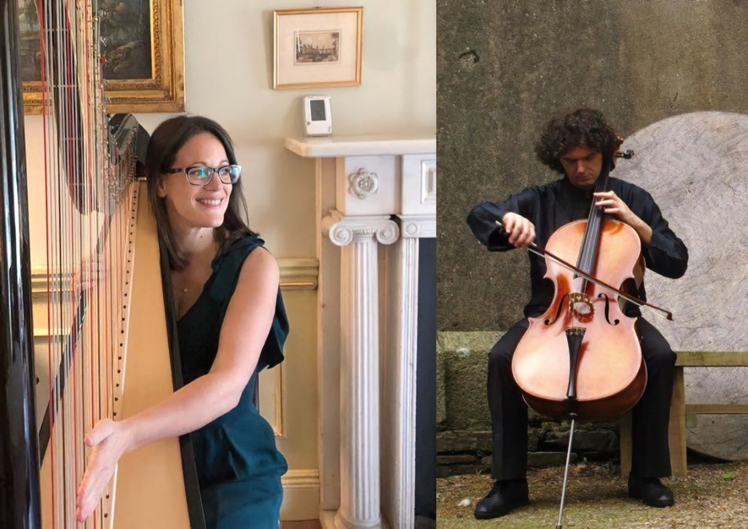

Listeners are invited to celebrate autumn in all its glory at the launch of a brand new season of Music at Midday in Crawford Art Gallery.

The much-loved Music at Midday programme of recitals and performances, a collaboration between Crawford Art Gallery and MTU School of Music, returns on the first Sunday in October with a special treat.

To welcome the days shortening and the leaves changing colour, harpist Anne-Marie Papin Labazordière and cellist Sokol Koka will team up to bring listeners on an autumnal musical journey with three specially selected pieces of music: Chants d’arrière saison (late season songs) by Bernard Andrès, Nocturne by Fermo Bellini and Promenade à l’automne (a walk in the autumn) by Marcel Tournier.

The first Sunday of every month until June 2024 becomes a date for every music lover’s diary at Crawford Art Gallery, with a free midday performance by talented students and staff of MTU School of Music.

A feast for the senses

Thomas Doyle, Conservatoire Coordinator at MTU School of Music, said the opening performance of the series, which will take place in the Crawford sculpture gallery, will be a true feast for the senses.

“With the unique pairing of harp and cello, in the surroundings of the sculpture gallery, it will be a feast for the eyes as well as the ears,” Mr Doyle said.

“The Music at Midday series is a real example of a cross-disciplinary partnership between MTU School of Music and Crawford Art Gallery. We’re excited to be back. It’s a wonderful opportunity for students and staff to perform in a very different environment so it’s wonderful to keep building on this partnership.”

The Music at Midday season to come will be full of treats for music lovers including wind chamber groups, string quartets and the Guitar Plus ensemble, as well as some Irish traditional music and unplugged-style performances from students of Popular Music.

Free to all

The fact that the midday concert series has free admission is “very in keeping with the School of Music’s ethos of inclusion and accessibility,” Mr Doyle said. “This is truly an opportunity for all members of the public, of all ages and from all walks of life, to come in to Crawford Art Gallery and enjoy the pleasure of live music.”

ENDS
About the musicians:

Harpist Anne-Marie Papin Labazordière is originally from France and now teaches harp in MTU Cork School of Music. She studied harp in Paris and London’s Royal College of Music. She moved to Ireland in 2007 and as a freelance musician has played with Cork Opera House Concert Orchestra, the National Symphony Orchestra and RTÉ Concert Orchestra.

Cellist Sokol Koka was born in Albania, received most of his musical education in Italy, played with the Milan Symphony Orchestra, and since 2009 he’s been a freelance chamber, ballet and orchestral musician in Ireland, playing with the RTÉ Concert Orchestra and the National Symphony Orchestra amongst others, and touring with Cork chanteuse Camille O’Sullivan.

Notes for editors:

Music at Midday is an ongoing collaboration between MTU Cork School of Music and Crawford Art Gallery, bringing a diverse season of musical performances to Crawford Art Gallery at midday on selected dates for the public to enjoy for free. Details on the programme for future dates will be published on www.crawfordartgallery.ie and on the gallery’s social media.

Music At Midday dates to come:

Sunday 5 November 2023
Sunday 3 December 2023
Sunday 4 February 2024
Sunday 3 March 2024
Sunday 7 April 2024
Sunday 5 May 2024
Sunday 9 June 2024

More about Crawford Art Gallery

Crawford Art Gallery is an Irish national cultural institution, dedicated to contemporary and historic visual art, located in a significant heritage building in the heart of Cork city. Offering a vibrant and dynamic programme of temporary exhibitions, it is also houses a collection of national importance which tells a compelling story of Cork and Ireland over the last three centuries.

Originally built in 1724 as the city’s Customs House, the Gallery is home to the famous Canova Casts, gifted to Cork two centuries ago. Featured in the gallery’s collection of over 3,000 objects are contemporary artists Aideen Barry, Gerard Byrne, Maud Cotter, Dorothy Cross, Tacita Dean, and Sean Scully as well as much-loved works by Irish artists James Barry, Harry Clarke, Mainie Jellett, Seán Keating, Daniel Maclise, Norah McGuinness, Edith Somerville, and Jack B. Yeats.

An oasis of calm and tranquility, Crawford Art Gallery is open seven days a week, free to enter, and a must-see for locals and tourists alike.

Opening Hours
Monday–Saturday 10.00am–5.00pm Late opening Thursdays until 8.00pm Sundays and Bank Holidays Gallery: 11am - 4pm Entry Free

Tours
Free Tours Sundays and Bank Holiday Mondays 2pm Free Tours on Thursday 6.30 pm . This project is in support of the Night-Time Economy and funded by The Department of Tourism, Culture, Arts, Gaeltacht, Sport and Media.

Café

The Green Room

A classic old world dining room in Cork’s cultural epicentre that mixes traditional food offerings alongside contemporary trends.
Open 7 days a week with opening times on www.crawfordartgallery.ie

