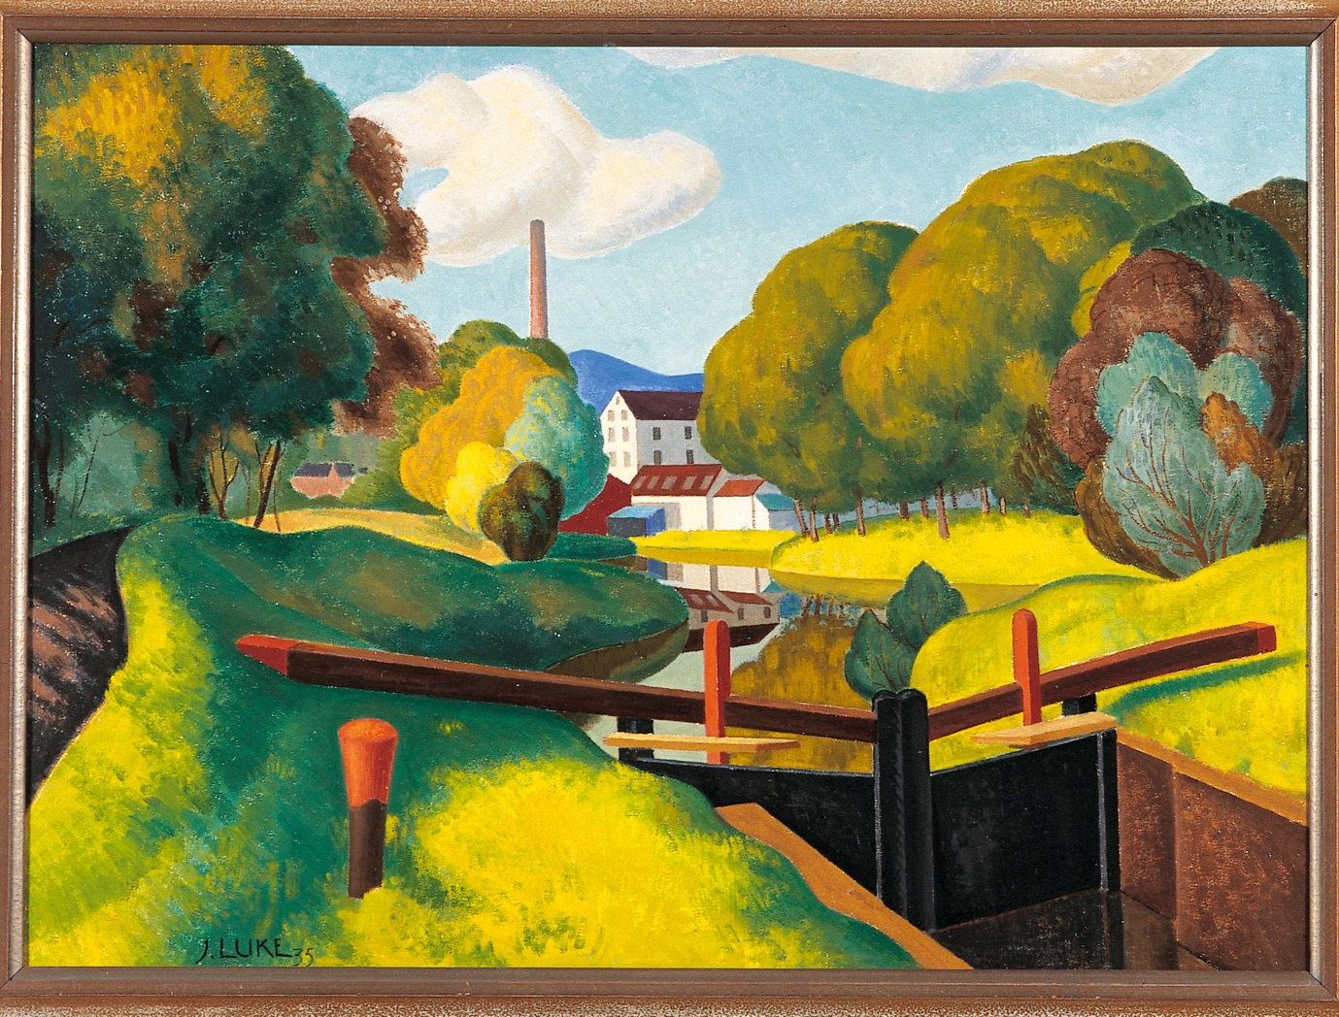

John Luke, The Lock at Edenderry, 1935. Collection Crawford Art Gallery, Cork © the artist’s estate

Press Release 11/04/24

Crawford Art Gallery loans 14 paintings to Northern Ireland’s Hillsborough Castle

In its largest ever loan from a National Cultural Institution in the Republic of Ireland, Hillsborough Castle has been loaned 14 paintings from Crawford Art Gallery’s collection.

Hillsborough Castle is set to display these significant artworks from Crawford Art Gallery’s collection in their State Drawing Room, viewable via public tours that focus on art across the island of Ireland.

The State Drawing Room at Hillsborough Castle has long been known for its impressive collection of Irish art and now this major rehang has been announced by Historic Royal Palaces, the charity which manages the castle and gardens.

33 new works of art are now on view in a veritable who’s who of Irish art, that has been made possible by collaborations with a variety of lenders, including Crawford Art Gallery in Cork.

Catherine Martin, the Minister for Tourism, Culture, Arts, Gaeltacht, Sport and Media said:

"I warmly welcome this loan of works by the Crawford Art Gallery to Hillsborough Castle. The sharing of art between institutions and historic venues across the island of Ireland assists in bringing important works to new audiences, and contributes to a shared understanding of the island, as seen through the eyes of each artist. While each work reflects the artistic and interpretative style of the individual artist, they all reflect a deep love for the island of Ireland in all its diverse landscapes and seascapes. In addition, the loan is also symbolic of a deepening overall relationship between North and South. I saw this first-hand at the recent plenary meeting of the re-established North South Ministerial Council. I wish to offer my thanks to the Crawford Art Gallery and to Hillsborough Castle and Gardens for bringing together the fourteen works with those from other collections to create what is a unique window into our shared heritage."

David Orr, Castle and Collections Manager at Hillsborough Castle and Gardens, said: “The Drawing Room at Hillsborough Castle has always been a haven of Irish art, a celebration of our magnificent land and seascapes right through to incredible royal portraits by Irish artists. We are hugely proud of this new collection, and excited to work with a significant range of lenders, including our largest ever from the Republic of Ireland, from Crawford Art Gallery in Cork.”

The paintings, most of which are either by artists born in Northern Ireland or with connections to NI in their work or lives, are all 20th century works frequently featuring Irish landscapes imbued with a distinctive sense of place such as:
- Landscapes by husband-and-wife painters Paul Henry, born in Belfast, and Grace Henry, born in Scotland. The couple lived on Achill Island for a time and were instrumental in founding the Society of Dublin Painters.
- Belfast-born Colin Middleton’s Moonlight Ballyholme (1953), painted when the artist moved with his family to live in Bangor, Co Down.
- Belfast artist John Luke’s The Locks at Edenderry (1944). A shipyard riveter in his late teens, he went on to study at Belfast College of Art, winning a scholarship to continue his studies at Slade School of Art in London.
Later in April, the gallery will add two further pieces – Off the Donegal Coast by Jack B. Yeats and The Dressmaker by Margaret Clarke – to this significant re-hang.

Hillsborough Castle, near Lisburn, is one of Historic Royal Palaces’ six sites. The others are Kew Palace, Kensington Palace, The Tower of London, Hampton Court Palace, and Banqueting House at Whitehall.

“Crawford Art Gallery are delighted to contribute to this cross-border initiative and are proud to be able to loan these significant works to Hillsborough Castle,” Crawford Art Gallery Director Mary McCarthy said.

“Northern Irish artists have made a major impact on the history and furtherance of Irish art, as evinced by the large number of works of immense beauty and interest by Northern Irish artists in Crawford Art Gallery’s collection.”

“We hope to collaborate on future exhibitions, and feel this is the foundation of a positive relationship, with much to build on. I think it is emblematic of the hunger, amongst the arts in particular, to continue to strengthen a mutually nurturing North-South relationship.”

Hillsborough Castle’s new display will be on view in the State Drawing Room until January 2027. Additional lenders of the collection include NI Civil Service, Down County Museum, Irish Linen Centre & Lisburn Museum, Co-Operation Ireland, Northern Ireland Office and King Charles III of the UK.

ENDS
​​
Dyane Hanrahan Marketing & Communications Manager E: dyanehanrahan@crawfordartgallery.ie T +353 (0) 21 4907856 M +353 (0) 86 8278151 www.crawfordartgallery.ie Crawford Art Gallery, Emmet Place, Cork, Ireland.

Ellie O’Byrne Press Officer
email: press@crawfordartgallery.ie Tel: +353 (0)87125 8446

Notes to editors
For a folder of hi-res images of the works on loan please click here.

The 14 works on loan from Crawford Art Gallery to Hillsborough Castle are:
- Sylvia Cooke-Collis, Donkeys in County Clare (c.1955)
- William Conor, The Horse Fair (c.1940)
- Margaret Clarke, The Dressmaker (1924)
- Jack B. Yeats, Off the Donegal Coast (1922)
- Grace Henry, Mountain Sheep (1946)
- Frank McKelvey, On the River Bann (unknown)
- May Guinness, Portrait Study (c.1930)
- John B. Vallely, Piper and Fiddler (unknown)
- Nano Reid, The Bottling Store (c.1959)
- Norah McGuinness, River to the Sea (1959)
- Gerard Dillon, Returning Islanders (c.1960)
- John Luke, The Lock at Edenderry (1935)
- Paul Henry, Lough Altan, Co. Donegal​ (c.1930)
- Colin Middleton, Moonlight Ballyholme (1953)
Historic Royal Palaces is a team of people who love and look after six of the most wonderful palaces in the world. We create space for spirits to stir and be stirred. We want everyone to feel welcome and accepted. We tell stories about the monarchs you know and the lives you don’t. We let people explore and we set minds racing. We are a charity and your support gives the palaces a future, for everyone. Registered charity number 1068852. For more information visit www.hrp.org.uk
With thanks to:
The trustees of the Sandys Trust (Registered Charity Number 1168357)
Northern Ireland Civil Service
NMD Museums - Down County Museum
Irish Linen Centre & Lisburn Museum
Co-Operation Ireland
Crawford Art Gallery, Cork
Northern Ireland Office
King Charles III of the UK
Emma Spence
More about Crawford Art Gallery:
Crawford Art Gallery is an Irish national cultural institution, dedicated to contemporary and historic visual art, located in a significant heritage building in the heart of Cork city. Offering a vibrant and dynamic programme of temporary exhibitions, it is also houses a collection of national importance which tells a compelling story of Cork and Ireland over the last three centuries.
Originally built in 1724 as the city’s Customs House, the Gallery is home to the famous Canova Casts, gifted to Cork two centuries ago. Featured in the gallery’s collection of over 3,000 objects are contemporary artists Aideen Barry, Gerard Byrne, Maud Cotter, Dorothy Cross, Tacita Dean, and Sean Scully as well as much-loved works by Irish artists James Barry, Harry Clarke, Mainie Jellett, Seán Keating, Daniel Maclise, Norah McGuinness, Edith Somerville, and Jack B. Yeats.

An oasis of calm and tranquility, Crawford Art Gallery is open seven days a week, free to enter, and a must-see for locals and tourists alike.

Opening Hours
Monday–Saturday 10.00am–5.00pm Late opening Thursdays until 8.00pm Sundays and Bank Holidays Gallery: 11am - 4pm Entry Free

Tours
Free Tours Sundays and Bank Holiday Mondays 2pm Free Tours on Thursday 6.30 pm . This project is in support of the Night-Time Economy and funded by The Department of Tourism, Culture, Arts, Gaeltacht, Sport and Media.

Café: The Green Room
A classic old world dining room in Cork’s cultural epicentre that mixes traditional food offerings alongside contemporary trends.
Opening times on www.crawfordartgallery.ie

Leagan Gaeilge:

14 phictiúr ar iasacht do Chaisleán Chromghlinne ó Ghailearaí Ealaíne Crawford - an iasacht is mó riamh ó Phoblacht na hÉireann

Tá Caisleán Chromghlinne réidh leis na saothair ealaíne shuntasacha seo a chur ar taispeáint ó bhailiúchán Ghailearaí Ealaíne Crawford ina bParlús Stáit, agus beidh siad mar chuid de thurais phoiblí ina ndíreofar ar an ealaín ar fud oileán na hÉireann.

Tá cáil ar an bParlús Stáit i gCaisleán Chromghlinne as a mbailiúchán mórthaibhseach d’ealaín Éireannach agus anois tá an t-athchrochadh fógartha ag Historic Royal Palaces, an carthanas a dhéanann an caisleán agus na gairdíní a bhainistiú.

Tá 33 saothar ealaíne nua ar taispeáint anois ina bhfuil léiriú ar na boic mhóra in ealaín Éireannach atá indéanta i gcomhar le hiasachtóirí éagsúla, lena n-áirítear Gailearaí Ealaíne Crawford i gCorcaigh.

Dúirt Catherine Martin, an tAire Turasóireachta, Cultúir, Ealaíon, Gaeltachta, Spóirt agus Meán:

“Cuirim fáilte mhór roimh an iasacht ealaíne seo ó Ghailearaí Ealaíne Crawford go Caisleán Chromghlinne. Cabhraíonn an ealaín, atá a comhroinnt idir institiúidí agus ionaid stairiúla ar fud oileán na hÉireann, le saothair thábhachtacha a chur ar fáil do lucht féachana nua agus cuireann sé leis an gcomhthuiscint den oileán, mar a fheictear é trí shúile gach ealaíontóra. Cé go léiríonn gach saothar stíl ealaíonta agus léirmhíniúcháin an ealaíontóra ar leith, léiríonn siad ar fad an grá domhain d’oileán na hÉireann ina thírdhreacha agus ina mhuirdhreacha éagsúla. Ina theannta sin, is siombail í an iasacht ar an gcaidreamh foriomlán atá ag fás idir an Tuaisceart agus an Deisceart. Thug mé an méid sin faoi deara i mo thaithí phearsanta ag cruinniú iomlánach den Chomhairle Aireachta Thuaidh/Theas atá athbhunaithe le gairid. Ba mhaith liom mo bhuíochas a chur in iúl do Ghailearaí Ealaíne Crawford agus do Chaisleán agus Gairdíní Chromghlinne as na ceithre shaothar déag a thabhairt le chéile ó bhailiúcháin eile chun léargas uathúil a chruthú ar ár n-oidhreacht roinnte.”

Bhí an méid seo a leanas le rá ag David Orr, Bainisteoir an Chaisleáin agus na mBailiúchán i gCaisleán agus Gairdíní Chromghlinne: “Ba thearmann d’ealaín Éireannach i gcónaí an Parlús i gCaisleán Chromghlinne, ceiliúradh ar ár dtírdhreacha agus ar ár muirdhreacha iontacha agus as sin go portráidí ríoga dochreidte ó ealaíontóirí Éireannacha. Táimid an-bhródúil as an mbailiúchán nua seo, agus táimid tiomanta obair le réimse suntasach iasachtóirí, lena n-áirítear ár n-iasachtóir is mó riamh ó Phoblacht na hÉireann, ó Ghailearaí Ealaíne Crawford i gCorcaigh.”

Is saothair ar fad ón 20ú haois iad na pictiúir, formhór acu ó ealaíontóirí a rugadh i dTuaisceart Éireann nó a bhfuil luí ar leith acu le Tuaisceart Éireann ina saol nó ina gcuid oibre, ina bhfuil baint ag tírdhreacha Éireannacha lán le hómós áite ar leith cosúil le:
- Tírdhreacha ó na healaíontóirí pósta Paul Henry, a rugadh i mBéal Feirste, agus Grace Henry, a rugadh in Albain. Bhí an lánúin ina gcónaí ar Acaill ar feadh tamaill agus bhí siad ceannródaíoch i gCumann na nEalaíontóirí i mBaile Átha Cliatha bhunú.
- Rugadh Colin Middleton i mBéal Feirste agus phéinteáil sé a shaothar Moonlight Ballyholme (1953), nuair a bhog an t-ealaíontóir lena theaghlach chun cónaí i mBeannchar, Contae an Dúin.
- The Locks at Edenderry (1944) ón ealaíontóir John Luke as Béal Feirste. Ba sheamaire longchlóis sna déaga deireanacha a bhí ann, a chuaigh le staidéar i gColáiste Ealaíne Bhéal Feirste, agus bhain sé scoláireacht amach chun leanúint lena chuid staidéar i Scoil Ealaíne Slade i Londain.
Níos déanaí in Aibreán, cuirfidh an gailearaí dhá shaothar breise leis an athchrochadh suntasach seo - Off the Donegal Coast le Jack B. Yeats agus The Dressmaker le Margaret Clarke.

Tá Caisleán Chromghlinne, in aice le Lios na gCearrbhach, ar cheann de na sé shuíomh um Historic Royal Palaces. Is iad na Páláis eile ná Pálás Key, Pálás Kensington, Túr Londain, Pálás Hampton Court, agus Banqueting House i Whitehall.

“Tá áthas ar Ghailearaí Ealaíne Crawford cur leis an tionscnamh trasteorann seo agus táimid bródúil as a bheith in ann na saothair shuntasacha seo a thabhairt ar iasacht go Caisleán Chromghlinne,” a deir Stiúrthóir Ghailearaí Ealaíne Crawford Mary McCarthy.

“Chuaigh ealaíontóirí Éireannacha Tuaisceartacha i gcion go mór ar stair agus ar dhul chun cinn na healaíne Éireannaí, mar atá léirithe sa líon mór saothar álainn agus spéisiúil ó ealaíontóirí Éireannacha Tuaisceartacha i mbailiúchán Ghailearaí Ealaíne Crawford.”

“Tá súil againn obair i gcomhar le taispeántais eile amach anseo, agus braithimid gur bunús é seo ar chaidreamh dearfach, agus beidh go leor le cur leis. Léiríonn sé an dúil, i measc na ndán ach go háirithe, leanúint le caidreamh Thuaidh Theas a chothú ón dá thaobh.”

Beidh taispeántas nua Chaisleán Chromghlinne ar taispeáint sa Pharlús Stáit go dtí Eanáir 2027. Áirítear ar na hiasachtóirí breise den bhailiúchán NI Civil Service, Down County Museum, Irish Linen Centre & Lisburn Museum, Co-Operation Ireland, Northern Ireland Office and King Charles III of the UK.

CRÍOCH

www.crawfordartgallery.ie Gailearaí Ealaíne Crawford, Plás Emmet, Corcaigh, Éire.

Dyane Hanrahan Bainisteoir Margaíochta & Cumarsáide
R: dyanehanrahan@crawfordartgallery.ie T +353 (0) 21 4907856 G +353 (0) 86 8278151

Ellie O’Byrne Oifigeach Preasa
R: press@crawfordartgallery.ie G +353 (0)87125 8446

Nótaí don Eagarthóir:

Le haghaidh tuilleadh íomhánna, cliceáil anseo.

Is iad na 14 shaothar atá ar iasacht ó Ghailearaí Ealaíne Crawford go Caisleán Chromghlinne ná:

- Sylvia Cooke-Collis, Donkeys in County Clare (c.1955)
- William Conor, The Horse Fair (c.1940)
- Margaret Clarke, The Dressmaker (1924)
- Jack B. Yeats, Off the Donegal Coast (1922)
- Grace Henry, Mountain Sheep (1946)
- Frank McKelvey, On the River Bann (unknown)
- May Guinness, Portrait Study (c.1930)
- John B. Vallely, Piper and Fiddler (unknown)
- Nano Reid, The Bottling Store (c.1959)
- Norah McGuinness, River to the Sea (1959)
- Gerard Dillon, Returning Islanders (c.1960)
- John Luke, The Lock at Edenderry (1935)
- Paul Henry, Lough Altan, Co. Donegal​ (c.1930)
- Colin Middleton, Moonlight Ballyholme (1953)
Is foireann daoine a thugann grá agus cúram do shé cinn de na páláis is iontaí ar domhan iad na Historic Royal Palaces Cruthaímid spás chun spioraid a spreagadh. Cuirimid fáilte roimh chách agus glacaimid le cách. Insímid scéalta faoi na ríthe a bhfuil aithne agat orthu agus fúthu siúd nach bhfuil. Ligimid do dhaoine fiosrú agus cuirimid intinní ag rásaíocht. Is carthanas muid agus tugann do thacaíocht todhchaí do na páláis, do chách. Uimhir Charthanais Chláraithe 1068852. Chun tuilleadh eolais a fháil, tabhair cuairt ar www.hrp.org.uk
Le buíochas:
The trustees of the Sandys Trust (Registered Charity Number 1168357)
Northern Ireland Civil Service
NMD Museums - Down County Museum
Irish Linen Centre & Lisburn Museum
Co-Operation Ireland
Crawford Art Gallery, Cork
Northern Ireland Office
King Charles III of the UK
Emma Spence

Tuilleadh eolais faoi Ghailearaí Ealaíne Crawford
Institiúid chultúrtha náisiúnta Éireannach is ea Gailearaí Ealaíne Crawford, atá tiomanta d’amharc-ealaín chomhaimseartha agus stairiúil, atá lonnaithe i bhfoirgneamh oidhreachta suntasach i gcroílár chathair Chorcaí. Cuireann sé clár bríomhar dinimiciúil de thaispeántais shealadacha ar fáil, agus tá bailiúchán ann freisin a bhfuil tábhacht náisiúnta aige agus a insíonn scéal iontach faoi Chorcaigh agus faoi Éirinn le trí chéad bliain anuas.

Tógadh an Gailearaí den chéad uair i 1724 mar Theach Custaim na cathrach, áit a bhfuil na Cásálacha cáiliúla Canova, a bronnadh ar Chorcaigh dhá chéad bliain ó shin. Tá ealaíontóirí comhaimseartha Aideen Barry, Gerard Byrne, Maud Cotter, Dorothy Cross, Tacita Dean, agus Sean Scully le feiceáil i mbailiúchán an ghailearaí, chomh maith le saothair leis na healaíontóirí Éireannacha James Barry, Harry Clarke, Mainie Jellett, Seán Keating, Daniel Maclise, Norah McGuinness, Edith Somerville, agus Jack B. Yeats.

Tá sé ina thearmann de shíocháin agus de shuaimhneas, tá Gailearaí Ealaíne Crawford oscailte seacht lá na seachtaine, saor in aisce le dul isteach, agus riachtanach le feiceáil do mhuintir na háite agus turasóirí araon.

Uaireanta Oscailte
Dé Luain-Dé Sathairn 10.00r.n-5.00i.n
An Déardaoin ag oscailt go dtí 8.00i.n
Dé Domhnaigh agus Gailearaí na Laethanta Saoire Bainc: 11r.n - 4i.n Iontráil shaor

Turais
Dé Domhnaigh tá turais Saor in Aisce agus Saoire Bainc Dé Luain 2 i.n
Turais saor in aisce ar an Déardaoin ag 6.30i.n.
Tá an tionscadal seo ag tacú leis an nGeilleagar Oíche agus á mhaoiniú ag an Roinn Turasóireachta, Cultúir, Ealaíon, Gaeltachta, Spóirt agus Meán.

Caifé: An Seomra Glas
Seomra bia clasaiceach domhanda i gcroílár cultúrtha Chorcaí ina measctar tairiscintí bia traidisiúnta in éineacht le treochtaí comhaimseartha.
Oscailte 7 lá na seachtaine le huaireanta oscailte ar www.crawfordartgallery.ie

