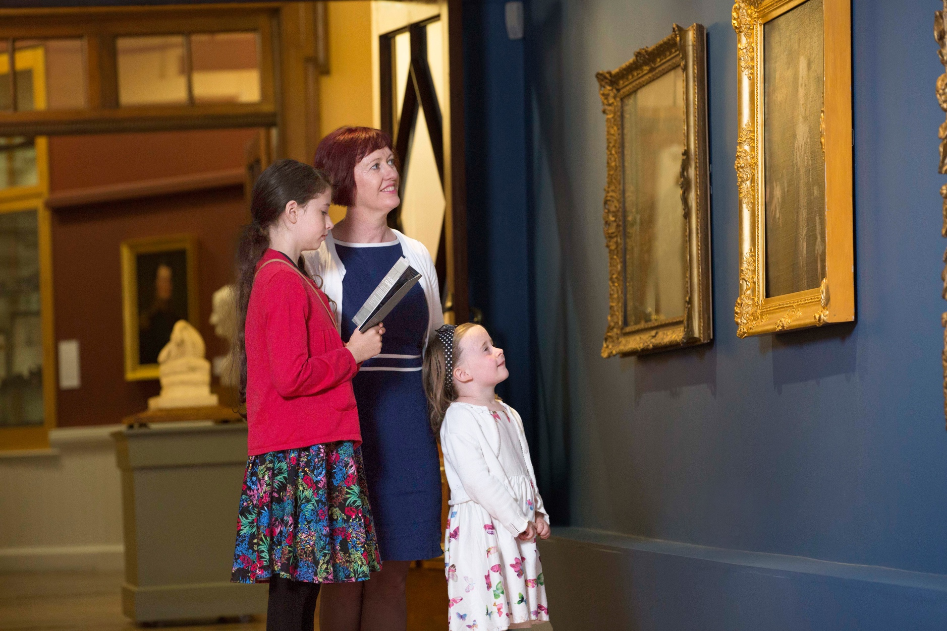

Gallery-goers can enjoy a range of free events and activities at Crawford Art Gallery for National Heritage Week 2024. Photo: Clare Keogh

Peep behind the scenes at a once-in-a-lifetime heritage project with Crawford Art Gallery’s free lunchtime talks all Heritage Week

Food for thought is what’s on the menu at Crawford Art Gallery for National Heritage Week 2024, with a series of free lunchtime talks with the gallery’s resident experts.

Delve deep into Crawford Art Gallery’s upcoming redevelopment, learn all about the art of conservation or take a curatorial tour of the latest exhibition as part of the gallery’s jam-packed programme for National Heritage Week, which runs from Heritage Open Day on August 17 until August 24.

Gallery director Mary McCarthy will outline the once-in-a-lifetime heritage project that is Crawford’s capital redevelopment with a talk titled Shaping the Future of Crawford Art Gallery.

In-house Production Manager Kathryn Coughlan will talk about what it takes to decant over 3,500 precious artworks from the building to prepare for the redevelopment, while conservator Dr Chiara Chillè will give the low-down on the art of conservation.

Other events include a curator’s tour of FROM SOURCE TO SEA, a River Lee themed exhibition, with Dr Michael Waldron, and a family friendly art workshop.

All the events being held in Crawford Art Gallery as part of this fun and thought-provoking programme are absolutely free, but some may be ticketed and require booking.

Full day-by-day programme of Heritage Week events:

Caring for the Collection with Dr Chiara Chillè

Friday 16th August, 13.15, Lower Gallery

Join us for a very special talk to kick off Heritage Week.

Art conservation is a vital tool in preserving cultural heritage and nobody believes this more passionately than conservator Dr Chiara Chillè, who is working in Crawford Art Gallery as they prepare to close for their capital redevelopment project. Join Chiara for a talk on the general principles of conservation followed by a more detailed look at her work with Crawford Art Gallery’s collection.

This event is free to attend but booking is essential. Reserve your place via Eventbrite.

Heritage Open Day FROM SOURCE TO SEA tour

Saturday 17 August, 2pm

Meeting point: Sculpture Galleries

Free Public Tour of exhibition: FROM SOURCE TO SEA with Artist and Tour guide Julie Forrester. Learn more about the exhibition and how it links to the National Heritage Week themes of Connections, Routes and Networks!

Free | Open to All

Heritage Open Day Family-friendly workshop

Saturday 17 August, 11-1pm

Gibson Landing

Join us for a hands on family friendly workshop. Get inspired by the exhibition from Source to Sea with artist Queenie O’Sullivan

Free | Open to All | Family friendly

Crating the Collection with Jean O’Donovan

Monday 19th August, 13.15, Lower Gallery

Join us for a very special talk as part of Heritage Week.

Over 3,000 precious artworks are set to be moved offsite by the end of 2024, for Crawford Art Gallery’s ambitious redevelopment project. How can such a precious collection be stored safely? Join Registrar Jean O’Donovan as she reveals her preparations for packing and moving Crawford Art Gallery’s diverse collection of artworks and objects.

This event is free to attend but booking is essential. Reserve your place via Eventbrite.

Decanting the Collection with Kathryn Coughlan

Wednesday 21st August, 13.15, Lower Gallery

Join us for a very special talk as part of Heritage Week.

The process and planning for decanting Crawford Art Gallery’s extensive collection is a huge undertaking. Production Manager Kathryn Coughlan talks through this fascinating process, as well as the potential risks involved in leaving a collection on-site during building work. Looking ahead, she will take us through what is involved with bringing the works back home once the capital redevelopment is complete.

This event is free to attend but booking is essential. Reserve your place via Eventbrite.

FROM SOURCE TO SEA – Heritage Week curator’s tour

Thursday 22 August, 1pm

Join us for a special Heritage Week tour of our exhibition, FROM SOURCE TO SEA, as curator Michael Waldron guides visitors on a journey along the course of the River Lee. And all from the comfort of the gallery!

This event is free to attend but booking is essential. Reserve your place via Eventbrite.

Shaping the future of Crawford Art Gallery with Mary McCarthy

Friday 23rd August, 13.15, Lower Gallery

Join our director Mary McCarthy to learn all about Crawford Art Gallery’s exciting new capital redevelopment. This is a special opportunity to hear about our 300-year-old building’s upcoming restoration along with the new elements which will give the Crawford significantly enhanced new spaces for exhibitions, Learn & Explore programmes as well as collection care and storage.

This event is free to attend but booking is essential. Reserve your place via Eventbrite.

ENDS

www.crawfordartgallery.ie Crawford Art Gallery, Emmet Place, Cork, Ireland.

Dyane Hanrahan Marketing & Communications Manager
E: dyanehanrahan@crawfordartgallery.ie T +353 (0) 21 4907856 M +353 (0) 86 8278151

Ellie O’Byrne Press Officer
E: press@crawfordartgallery.ie M +353 (0)87125 8446

Notes to Editor: for extra images please click here.

About Crawford Art Gallery

Crawford Art Gallery is an Irish National Cultural Institution (NCI) dedicated to contemporary and historic visual art, located in a significant heritage building in the heart of Cork city. Offering a dynamic programme of temporary exhibitions, it also houses a collection of national importance which tells the compelling story of Cork and Ireland over the last three centuries.

Originally built in 1724 as the city’s Customs House, the Gallery is home to the famous Canova Casts, gifted to Cork two centuries ago. Featured in the gallery’s collection of over 3,000 objects are contemporary artists Aideen Barry, Gerard Byrne, Maud Cotter, Dorothy Cross and Sean Scully as well as much-loved works by Irish artists James Barry, Harry Clarke, Mainie Jellett, Seán Keating, Daniel Maclise, Norah McGuinness and Jack B. Yeats.

About Crawford Art Gallery’s Capital Redevelopment

Crawford Art Gallery closes in Autumn 2024 for two years to undergo an enormously exciting capital redevelopment project.

This multi-million euro investment will increase gallery space by 45%, preserve and protect three centuries of existing built heritage, and create a cultural legacy for a new century as Cork continues to grow.

The project is a Government of Ireland 2040 project funded by the department of Tourism, Culture, Arts, Gaeltacht, Sport and Media in partnership with the Office of Public Works (OPW).

The award-winning Grafton Architects have worked on a redevelopment design that includes a new Learn and Explore facility for public engagement, significant storage for the National Collection at Crawford, a new entrance, and a dramatically improved public realm including new café facing onto Half Moon Street.

The building’s entrance will be reoriented to Emmet Place in line with the original Customs House layout dating to 1724.

A large new public gallery space will be created five stories above Cork City, creating a new vantage point for visitors to view city centre landmarks including Shandon and St Finbarre’s Cathedral.

Opening Hours

Open Daily
Monday–Saturday 10.00am–5.00pm Late opening Thursdays until 8.00pm Sundays and Bank Holidays Gallery: 11am - 4pm Entry Free

Tours
Free Tours Sundays and Bank Holiday Mondays 2pm Free Tours on Thursday 6.30 pm . This project is in support of the Night-Time Economy and funded by The Department of Tourism, Culture, Arts, Gaeltacht, Sport and Media.

Leagan Gaeilge:

Súil laistiar den chúlra le cainteanna am lóin saor in aisce Ghailearaí Ealaíne Crawford ar feadh Sheachtain na hOidhreachta

Beidh neart rudaí deasa le blaiseadh ón mbiachlár ag Gailearaí Ealaíne Crawford do Sheachtain na hOidhreachta seo, le sraith de chainteanna am lóin saor in aisce le saineolaithe an ghailearaí.

Tum isteach in athfhorbairt Ghailearaí Ealaíne Crawford a bheidh ag teacht aníos go luath, foghlaim gach rud faoin scil caomhnaithe nó glac turas coimeádaíochta den taispeántas is déanaí mar chuid de chlár pacáilte an ghailearaí do Sheachtain Náisiúnta na hOidhreachta 2024, a bheidh ar siúl ó Lá Oscailte na hOidhreachta an 17 Lúnasa go dtí 24 Lúnasa.

Tabharfaidh stiúrthóir an Ghailearaí Mary McCarthy achoimre ar an togra oidhreachta atá mar athfhorbairt chaipitil Ghailearaí Ealaíne Crawford le caint dar teideal Shaping the Future of Crawford.

Labhróidh Kathryn Coughlan, Bainisteoir Léirithe intí ar an gcaoi le hos cionn 3,500 saothar ealaíne luachmhar a bhogadh ón bhfoirgneamh le hullmhú don athfhorbairt, agus tabharfaidh an caomhnóir Dr Chiara Chillè cur síos dúinn ar an scil caomhnaithe.

Ar na himeachtaí eile, beidh turas an choimeádaí ó FROM SOURCE TO SEA, taispeántas téamúil na Laoi, leis an Dr Michael Waldron, agus ceardlann ealaíne oiriúnach do theaghlaigh.

Tá na himeachtaí ar fad a bheidh ar siúl i nGailearaí Ealaíne Crawford mar chuid den chlár spraíúil a bhfuil ábhar machnaimh ann saor in aisce, ach beidh ticéad ag teastáil do chuid acu agus is gá áirithint a dhéanamh.

Clár iomlán imeachtaí Sheachtain na hOidhreachta ó lá go lá:

Cúram a thabhairt don Bhailiúchán leis an Dr Chiara Chillè

Dé hAoine, 16 Lúnasa, 13.15, An Gailearaí Íochtarach

Bí linn don chaint speisialta chun tús a chur le Seachtain na hOidhreachta.

Is uirlis thábhachtach é caomhnú ealaíne chun oidhreacht chultúrtha a chaomhnú agus ní chreideann aon duine é sin níos paiseanta ná an caomhnóir, an Dr Chiara Chillè, atá ag obair i nGailearaí Ealaíne Crawford agus iad ag ullmhú le dúnadh don tionscadal athfhorbartha caipitil. Éist le Chiara ag míniú na mbunphrionsabal caomhnaithe tar éis léargas mionsonraithe ar a saothar i mbailiúchán Ghailearaí Ealaíne Crawford.

Tá an t-imeacht seo saor in aisce ach is gá áirithintí a dhéanamh. Cuir d’áit in áirithe trí Eventbrite.

Lá Oscailte Oidhreachta le turas faoi FROM SOURCE TO SEA

Dé Sathairn, an 17 Iúil, 2pm

Ionad chun teacht le chéile: Gailearaithe Dealbhóireachta

Turas ar an taispeántais Saor in aisce don Phobal: FROM SOURCE TO SEA leis an Ealaíontóir agus an Treoraí turais Julie Forrester. Foghlaim níos mó faoin taispeántas agus an chaoi a nascann sé le téamaí Sheachtain Náisiúnta na hOidhreachta de Naisc, Bealaí agus Líonraí!

Saor in aisce do gach cuairteoir

Ceardlann oiriúnach do theaghlaigh don Lá Oscailte Oidhreachta

Dé Sathairn, an 17 Iúil, 11-1pm

Gibson Landing

Bí linn do cheardlann teagmhálach atá oiriúnach do theaghlaigh. Faigh spreagadh ón taispeántas FROM SOURCE TO SEA leis an ealaíontóir Queenie O’Sullivan

Saor in aisce do gach cuairteoir

An bailiúchán a chur i gCliathbhoscaí le Jean O’Donovan

Dé Luain, 19 Lúnasa, 13.15, An Gailearaí Íochtarach

Bí linn don chaint speisialta mar chuid de Sheachtain na hOidhreachta.

Beidh os cionn 3,000 saothar ealaíne luachmhar le bogadh lasmuigh den ghailearaí roimh dheireadh 2024, do thionscadal athfhorbartha uaillmhianach Ghailearaí Ealaíne Crawford. Cén chaoi ar féidir bailiúchán chomh luachmhar sin a stóráil go sábháilte? Bí leis an gCláraitheoir Jean O’Donovan agus í ag léiriú a n-ullmhúcháin le bailiúchán éagsúil shaothair ealaíne agus rudaí Ghailearaí Ealaíne Crawford a phacáil agus a bhogadh.

Tá an t-imeacht seo saor in aisce ach is gá áirithintí a dhéanamh. Cuir d’áit in áirithe trí Eventbrite.

An bailiúchán a bhogadh le Kathryn Coughlan

Dé Céadaoin, 21 Lúnasa, 13.15, An Gailearaí Íochtarach

Bí linn don chaint speisialta seo mar chuid de Sheachtain na hOidhreachta.

Is gnóthas ollmhór é próiseas agus pleanáil bhailiúchán fairsingíoch Ghailearaí Ealaíne Crawford a bhogadh. Beidh an Bainisteoir Léirithe Kathryn Coughlan ag labhairt faoin bpróiseas an-spéisiúil seo, mar aon leis na contúirtí féideartha a bhaineann le bailiúchán a fhágáil ar an láthair le linn obair thógála. Ag féachaint chun cinn, tabharfaidh sí achoimre dúinn ar a bhfuil i gceist chun na saothair a thabhairt abhaile nuair a bheidh an athfhorbairt chaipitil curtha i gcrích.

Tá an t-imeacht seo saor in aisce ach is gá áirithintí a dhéanamh. Cuir d’áit in áirithe trí Eventbrite.

FROM SOURCE TO SEA - turas an choimeádaí do Sheachtain na hOidhreachta

Déardaoin, an 22 Lúnasa, 1pm

Bí linn i gcomhair turas speisialta dár dtaispeántas nua, FROM SOURCE TO SEA, agus an coimeádaí an Dr Michael Waldron do do threorú ar thuras le hais chúrsa na Laoi. Agus an méid sin ar fad agus tú ar do sháimhín só sa ghailearaí!

Tá an t-imeacht seo saor in aisce ach is gá áirithintí a dhéanamh. Cuir d’áit in áirithe trí Eventbrite.

Cruth a chur ar an Todhchaí le Mary McCarthy

Dé hAoine, 23 Lúnasa, 13.15, An Gailearaí Íochtarach

Bí linn lenár stiúrthóir Mary McCarthy chun gach rud faoi athfhorbairt chaipitil nua Ghailearaí Ealaíne Crawford a fhoghlaim. Is deis speisialta é seo chun foghlaim faoinár n-athchóiriú, a bheidh ag tarlú go luath, ar ár bhfoirgneamh atá 300 bliain d’aois mar aon leis na gnéithe nua a chuirfidh le spásanna nua taispeántais do Ghailearaí Ealaíne Crawford, cláir Foghlama agus Fiosraithe mar aon le cúram bailiúcháin agus stórála.

Tá an t-imeacht seo saor in aisce ach is gá áirithintí a dhéanamh. Cuir d’áit in áirithe trí Eventbrite.

CRÍOCH

www.crawfordartgallery.ie Gailearaí Ealaíne Crawford, Plás Emmet, Corcaigh, Éire.

Dyane Hanrahan Bainisteoir Margaíochta & Cumarsáide
R: dyanehanrahan@crawfordartgallery.ie T +353 (0) 21 4907856 M +353 (0) 86 8278151

Ellie O’Byrne Preasoifigeach
R: press@crawfordartgallery.ie M +353 (0)87125 8446

Nótaí don Eagarthóir: chun breis íomhánna a fheiceáil, cliceáil anseo.

Maidir le Gailearaí Ealaíne Crawford

Is institiúid chultúrtha náisiúnta é Gailearaí Ealaíne Crawford atá suite i bhfoirgneamh oidhreachta suntasach i gcroílár chathair Chorcaí agus atá tiomnaithe do na hamharc-ealaíona, go stairiúil agus go comhaimseartha araon. Agus é ag cur clár fuinniúil taispeántas sealadach ar fáil, tá bailiúchán náisiúnta tábhachtach faoina dhíon freisin a insíonn scéal spéisiúil Chorcaí agus na hÉireann le trí chéad bliain anuas.

Tógadh ar dtús i 1724 é mar Theach Custaim na cathrach agus tá na Múnlaí Canova cáiliúla ar taispeáint sa Ghailearaí, a bronnadh ar Chorcaigh dhá chéad bliain ó shin. Tá os cionn 3,000 saothar i mbailiúchán an ghailearaí. Ina measc tá na healaíontóirí comhaimseartha Aideen Barry, Gerard Byrne, Maud Cotter, Dorothy Cross agus Seán Scully mar aon le saothair a bhfuil gean mór orthu leis na healaíontóirí Éireannacha James Barry, Harry Clarke, Mainie Jellett, Seán Keating, Daniel Maclise, Norah McGuinness agus Jack B. Yeats.

Maidir le hAthfhorbairt Chaipitil Ghailearaí Ealaíne Crawford 2024-2026

Beidh Gailearaí Ealaíne Crawford dúnta i bhfómhar 2024 ar feadh dhá bhliain chun tabhairt faoi thogra athfhorbartha caipitil.

Cuirfidh an infheistíocht, ar fiú na milliúin euro é, 45% breise le spás an ghailearaí, agus déanfaidh sé trí chéad bliain d’oidhreacht thógtha a chaomhnú agus a chosaint, agus cruthófar oidhreacht chultúrtha don ghlúin amach romhainn de réir mar a bheidh Corcaigh ag leanúint ag fás.

Is togra de chuid Thograí Rialtas na hÉireann 2040 é atá ag fáil maoiniú ón Roinn Turasóireachta, Cultúir, Ealaíon, Gaeltachta, Spóirt agus Meáin i gcomhar le hOifig na nOibreacha Poiblí (OPW).

Tá Grafton Architects a bhfuil gradaim bainte acu tar éis obair a dhéanamh ar dhearadh athfhorbartha lena n-áirítear áis Foghlam agus Fiosraithe nua le rannpháirtíocht ghníomhach, stóráil shuntasach don Bhailiúchán Náisiúnta i nGailearaí Crawford, bealach isteach nua, agus spás poiblí a bheidh feabhsaithe go mór lena n-áirítear caifé nua ar Shráid na Leathghealaí.

Beidh bealach isteach an fhoirgnimh curtha ar ais go Plás Emmet de réir leagan amach Theach an Chustaim a chuaigh siar go 1724.

Cruthófar spás gailearaí mór nua le cúig urlár ag féachaint amach ar Chathair Chorcaí, a chruthaíonn radharc do chuairteoirí chun féachaint ar shainchomharthaí i lár na cathrach lena n-áirítear An Seandún agus Ardeaglais Naomh Fionnbarra.

Uaireanta Oscailte

Oscailte go Laethúil
Dé Luain-Dé Sathairn 10.00am–5.00pm Oscailte go déanach Déardaoin go dtí 8.00pm Dé Domhnaigh agus Laethanta Saoire Bainc: 11am - 4pm
Cead isteach Saor in aisce

Turais
Turais Saor in aisce Dé Domhnaigh agus Luain Saoire Bainc 2pm Turais Saor in aisce Déardaoin 6.30pm. Tacaíonn an tionscadal seo le Geilleagar san Oíche agus faigheann sé tacaíocht ón Roinn Turasóireachta, Cultúir, Ealaíon, Gaeltachta, Spóirt agus Meáin.

