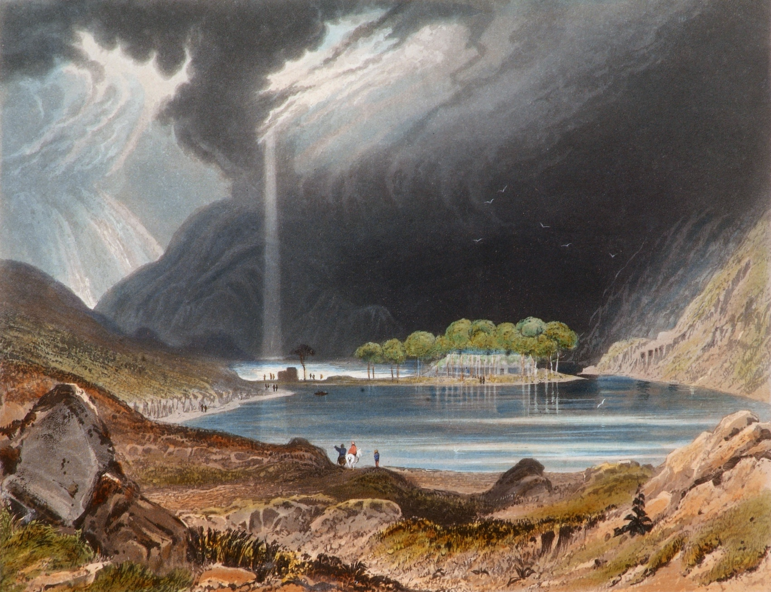

George Petrie, Gougane Barra, Co. Cork, 1835. Collection Crawford Art Gallery, Cork.

Exhibition celebrating the River Lee opens at Crawford Art Gallery

An exhibition following the course of the River Lee, from its origins in the Shehy Mountains and Gougane Barra in the west to its meeting with the Celtic Sea at the mouth of Cork Harbour in the east, has opened at Crawford Art Gallery.

Spanning historic and contemporary artworks from the collection, FROM SOURCE TO SEA celebrates the culture of Cork’s mighty Lee and its tributaries.

Artworks from the 1750s through to the present day are featured in the exhibition. Each painting, drawing, print, and sculpture offers a perspective on the river, the stories it has carried and collected, the places and people it has shaped, and the changes it has inevitably borne.

The exhibition features much-loved paintings, ranging from John Butts’ View of Cork from Audley Place (c.1750) and Whipping the Herring out of Town (c.1800) by Nathaniel Grogan, to George Mounsey Wheatley Atkinson’s Paddle Steamer Entering the Port of Cork (1842) and Skellig Night on South Mall (1845) by James Beale. These are joined by the work of artists Sarah Grace Carr, Kate Dobbin, John Fitzgerald, Robert Gibbings,

Patrick Hennessy, Seán Keating, Diarmuid Ó Ceallacháin, and George Petrie.

Recent acquisitions by Ita Freeney, Bernadette Kiely, and Donald Teskey offer new contexts, while portraits by Séamus Murphy, Nano Reid, and Eileen Healy recall rich tales from the Lee Valley, including The Tailor and Ansty and the inimitable voice of Cónal Creedon.

Michael Waldron, curator of the exhibition, says: ‘Following our popular exhibitions focusing on Cork city and harbour, it’s been such a pleasure to take a journey along the River Lee itself. I hope visitors will take as much enjoyment in following its course, connecting with the river’s rich history and culture, and maybe even get inspired to take their own stroll at Gougane Barra, Lee Fields, or the Marina.’

FROM SOURCE TO SEA is on from 22 June to 22 September in the Gibson Galleries at Crawford Art Gallery.

ENDS

www.crawfordartgallery.ie Crawford Art Gallery, Emmet Place, Cork, Ireland.

Dyane Hanrahan Marketing & Communications Manager
E: dyanehanrahan@crawfordartgallery.ie T +353 (0) 21 4907856 M +353 (0) 86 8278151

Ellie O’Byrne Press Officer
E: press@crawfordartgallery.ie M +353 (0)87125 8446

Notes for editors: for extra images please click here.

About Crawford Art Gallery

Crawford Art Gallery is an Irish National Cultural Institution (NCI) dedicated to contemporary and historic visual art, located in a significant heritage building in the heart of Cork city. Offering a dynamic programme of temporary exhibitions, it also houses a collection of national importance which tells the compelling story of Cork and Ireland over the last three centuries.

Originally built in 1724 as the city’s Customs House, the Gallery is home to the famous Canova Casts, gifted to Cork two centuries ago. Featured in the gallery’s collection of over 3,000 objects are contemporary artists Aideen Barry, Gerard Byrne, Maud Cotter, Dorothy Cross and Sean Scully as well as much-loved works by Irish artists James Barry, Harry Clarke, Mainie Jellett, Seán Keating, Daniel Maclise, Norah McGuinness and Jack B. Yeats.

About Crawford Art Gallery’s Capital Redevelopment 2024-2026

Crawford Art Gallery closes in Autumn 2024 for two years to undergo an enormously exciting capital redevelopment project.

This multi-million euro investment will increase gallery space by 45%, preserve and protect three centuries of existing built heritage, and create a cultural legacy for a new century as Cork continues to grow.

The project is a Government of Ireland 2040 project funded by the department of Tourism, Culture, Arts, Gaeltacht, Sport and Media in partnership with the Office of Public Works (OPW).

The award-winning Grafton Architects have worked on a redevelopment design that includes a new Learn and Explore facility for public engagement, significant
storage for the National Collection at Crawford, a new entrance, and a dramatically improved public realm including new café facing onto Half Moon Street.

The building’s entrance will be reoriented to Emmet Place in line with the original Customs House layout dating to 1724.

A large new public gallery space will be created five stories above Cork City, creating a new vantage point for visitors to view city centre landmarks including Shandon and St Finbarre’s Cathedral.

Opening Hours
Monday–Saturday 10.00am–5.00pm Late opening Thursdays until 8.00pm Sundays and Bank Holidays Gallery: 11am - 4pm Entry Free

Tours
Free Tours Sundays and Bank Holiday Mondays 2pm Free Tours on Thursday 6.30 pm. This project is in support of the Night-Time Economy and funded by The Department of Tourism, Culture, Arts, Gaeltacht, Sport and Media.

Leagan Gaeilge:

Osclaíonn taispeántas a dhéanann ceiliúradh ar an Laoi i nGailearaí Ealaíne Crawford

Tá taispeántas nua, a leanann cúrsa na Laoi óna bunús ar Chnoic na Seithe agus Guagán Barra san iarthar go sroicheann sí an Mhuir Cheilteach ag béal Chuan Chorcaí san oirthear, oscailte anois i nGailearaí Ealaíne Crawford.

Déanann FROM SOURCE TO SEA na saothair stairiúla agus chomhaimseartha ón mbailiúcháin a cheiliúradh mar aon le cultúr na Laoi agus a craobhaibhneacha i gCorcaigh.

Beidh baint ag saothair ealaíne ó na 1750idí go dtí an lá atá inniu ann sa taispeántas, agus é ag rianú léargais den abhainn agus na scéalta a cruthaíodh agus a bailíodh.

Tá saothair ealaíne a bhfuil gean mór orthu, cosúil le saothair de chuid John Butts’ View of Cork from Audley Place (c.1750) agus saothair le George Mounsey Wheatley Atkinson Paddle Steamer Entering the Port of Cork (1842), in éineacht le saothair na n-ealaíontóirí Sarah Grace Carr, Kate Dobbin, John Fitzgerald, Robert Gibbings, Nathaniel Grogan, Patrick Hennessy, Samuel McDonnell, agus George Petrie sa taispeántas seo agus iad coimeádta ag Coimeádóir Ghailearaí Ealaíne Crawford na mBailiúchán, Michael Waldron.

Cuireann na saothair is déanaí a fuarthas le Ita Freeney, Bernadette Kiely, agus Donald Teskey comhthéacsanna nua ar fáil, agus tugann saothair le Séamus Murphy agus Nano Reid léargais shaibhre a thabhairt chun cuimhne ó Ghleann na Laoi le ‘Father Prout’ agus The Tailor and Ansty.

Beidh FROM SOURCE TO SEA ar taispeáint idir 22 Meitheamh agus 22 Meán Fómhair i nGailearaithe Gibson i nGailearaí Ealaíne Crawford.

CRÍOCH

www.crawfordartgallery.ie Gailearaí Ealaíne Crawford, Plás Emmet, Corcaigh, Éire.

Dyane Hanrahan Bainisteoir Margaíochta & Cumarsáide

R: dyanehanrahan@crawfordartgallery.ie T +353 (0) 21 4907856 M +353 (0) 86 8278151

Ellie O’Byrne Preasoifigeach
R: press@crawfordartgallery.ie M +353 (0)87125 8446

Nótaí don Eagarthóir: chun breis íomhánna a fheiceáil, cliceáil anseo.

Maidir le Gailearaí Ealaíne Crawford

Is institiúid chultúrtha náisiúnta é Gailearaí Ealaíne Crawford atá suite i bhfoirgneamh oidhreachta suntasach i gcroílár chathair Chorcaí agus atá
tiomnaithe do na hamharc-ealaíona, go stairiúil agus go comhaimseartha araon. Agus é ag cur clár fuinniúil taispeántas sealadach ar fáil, tá bailiúchán náisiúnta tábhachtach faoina dhíon freisin a insíonn scéal spéisiúil Chorcaí agus na hÉireann le trí chéad bliain anuas.

Tógadh ar dtús i 1724 é mar Theach Custaim na cathrach agus tá na Múnlaí Canova cáiliúla ar taispeáint sa Ghailearaí, a bronnadh ar Chorcaigh dhá chéad bliain ó shin. Tá os cionn 3,000 saothar i mbailiúchán an ghailearaí. Ina measc tá na healaíontóirí comhaimseartha Aideen Barry, Gerard Byrne, Maud Cotter, Dorothy Cross agus Seán Scully mar aon le saothair a bhfuil gean mór orthu leis na healaíontóirí Éireannacha James Barry, Harry Clarke, Mainie Jellett, Seán Keating, Daniel Maclise, Norah McGuinness agus Jack B. Yeats.

Maidir le hAthfhorbairt Chaipitil Ghailearaí Ealaíne Crawford 2024-2026

Beidh Gailearaí Ealaíne Crawford dúnta i bhfómhar 2024 ar feadh dhá bhliain chun tabhairt faoi thogra athfhorbartha caipitil.

Cuirfidh an infheistíocht, ar fiú na milliúin euro é, 45% breise le spás an ghailearaí, agus déanfaidh sé trí chéad bliain d’oidhreacht thógtha a chaomhnú agus a chosaint, agus cruthófar oidhreacht chultúrtha don ghlúin amach romhainn de réir mar a bheidh Corcaigh ag leanúint ag fás.

Is togra de chuid Thograí Rialtas na hÉireann 2040 é atá ag fáil maoiniú ón Roinn Turasóireachta, Cultúir, Ealaíon, Gaeltachta, Spóirt agus Meáin i gcomhar le hOifig na nOibreacha Poiblí (OPW).

Tá Grafton Architects a bhfuil gradaim bainte acu tar éis obair a dhéanamh ar dhearadh athfhorbartha lena n-áirítear áis Foghlam agus Fiosraithe nua le rannpháirtíocht ghníomhach, stóráil shuntasach don Bhailiúchán Náisiúnta i nGailearaí Crawford, bealach isteach nua, agus spás poiblí a bheidh feabhsaithe go mór lena n-áirítear caifé nua ar Shráid na Leathghealaí.

Beidh bealach isteach an fhoirgnimh curtha ar ais go Plás Emmet de réir leagan amach Theach an Chustaim a chuaigh siar go 1724.

Cruthófar spás gailearaí mór nua le cúig urlár ag féachaint amach ar Chathair Chorcaí, a chruthaíonn radharc do chuairteoirí chun féachaint ar

shainchomharthaí i lár na cathrach lena n-áirítear An Seandún agus Ardeaglais Naomh Fionnbarra.

Uaireanta Oscailte
Dé Luain-Dé Sathairn 10.00am–5.00pm Oscailte go déanach Déardaoin go dtí 8.00pm Dé Domhnaigh agus Laethanta Saoire Bainc: 11am - 4pm
Cead isteach Saor in aisce

Turais
Turais Saor in aisce Dé Domhnaigh agus Luain Saoire Bainc 2pm Turais Saor in aisce Déardaoin 6.30pm. Tacaíonn an tionscadal seo le Geilleagar san Oíche agus faigheann sé tacaíocht ón Roinn Turasóireachta, Cultúir, Ealaíon, Gaeltachta, Spóirt agus Meáin.

