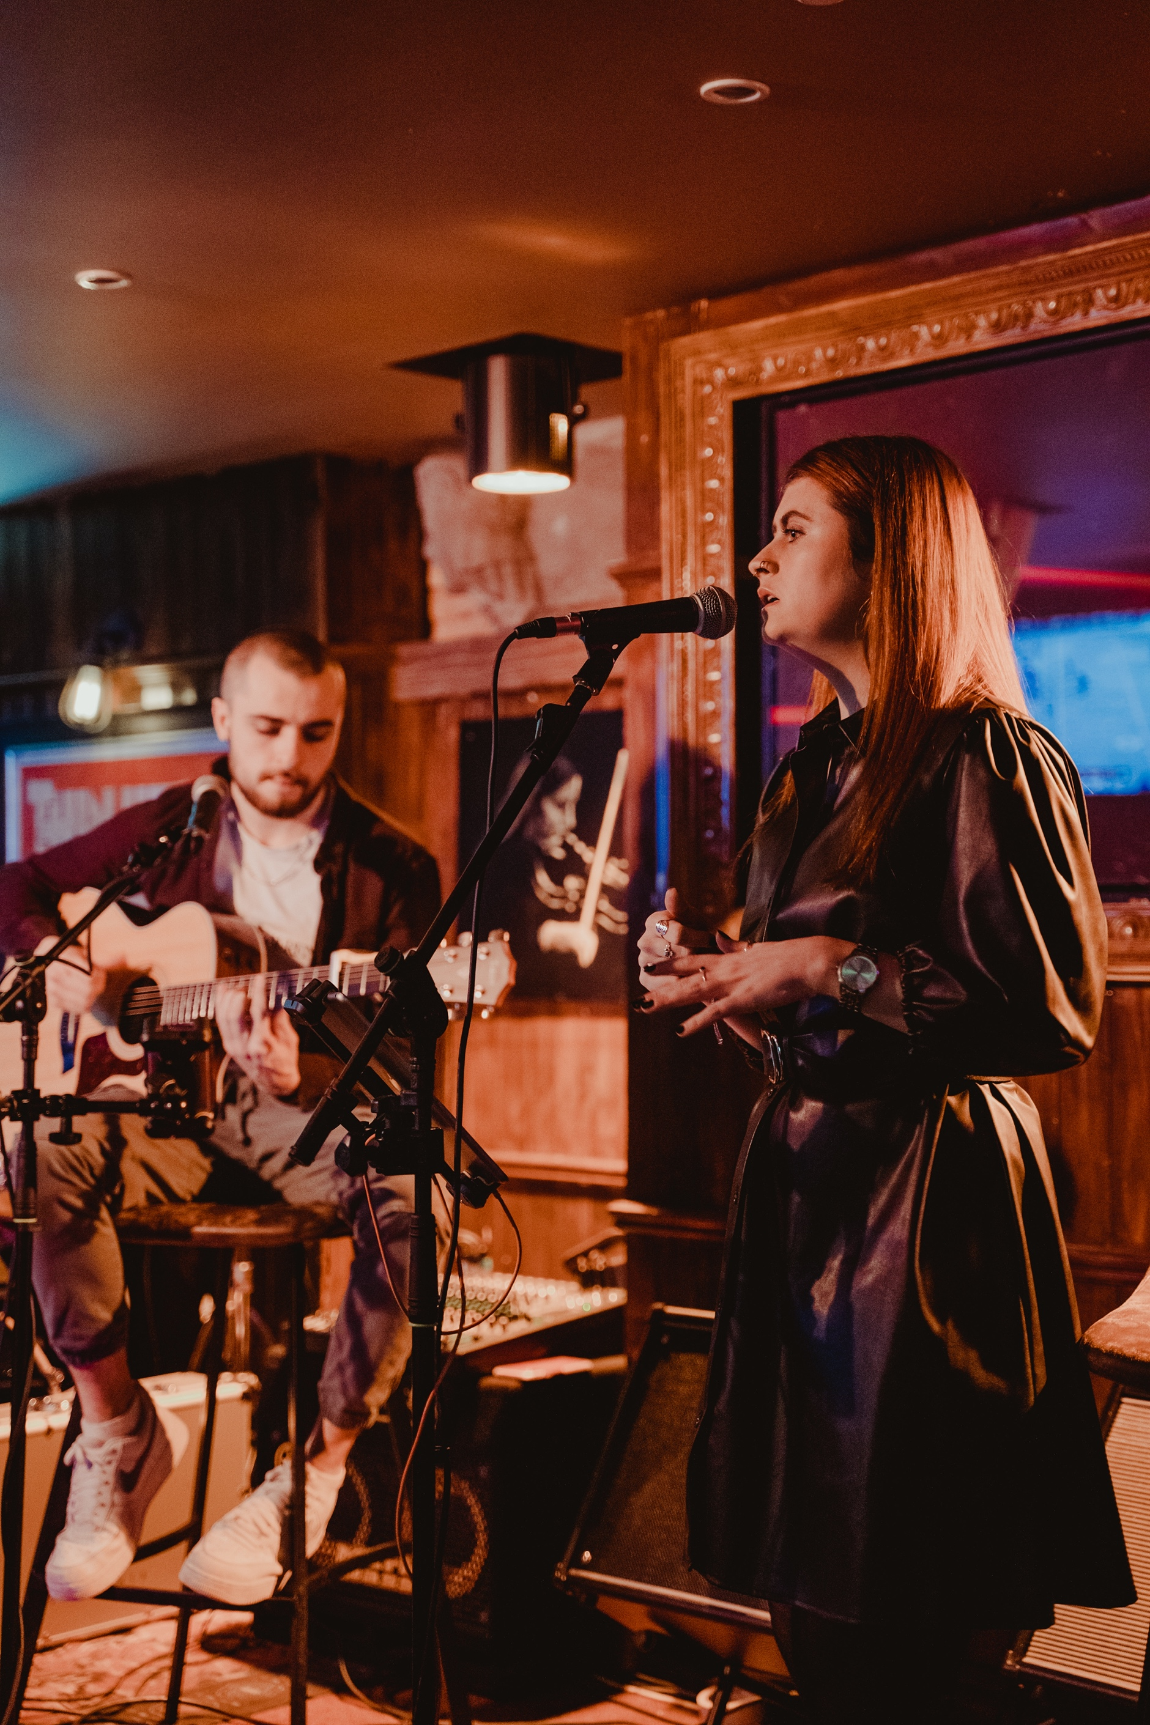
Steven Falvey and Lilly Patton. Photo: Philip Corkery

PRESS RELEASE 24/05/23

Steven Falvey and Lilly Patton fill Crawford with music.

The very successful partnership between MTU Cork School of Music and Crawford Art Gallery presents the final Music at Midday before a break for the summer. The programme returns in the Autumn where it will run for another year until the Gallery closure in the Autumn of 2024.

The upcoming concert will feature a dynamic pop duo, a vocalist and a guitarist, who are students at MTU Cork School of Music. Steven Falvey and Lilly Patton are two musicians from Cork who perform regularly in the city’s busiest venues, both independently and as a two piece.

This dynamic event will mark the last Music at Midday of the academic year and will showcase the extraordinary talent of students from MTU Cork School of Music.

Going by the name ‘Old Souls’, Steven and Lilly are a match made in heaven. Their harmonies are tight and their voices complement each other perfectly in a beautiful mix of classic covers and tasteful original music.

Originally from Ballinspittle, Lilly has a strong background in blues music, drawing inspiration from her grandmother, herself a renowned jazz singer in Cork for over fifty years. Many say the tone and timbre of Lilly’s voice is unique, championing a low husky register and the ability to delve into low notes with ease!

Steven is originally from Ballincollig and developed his performance skills while busking on the streets of Dublin. Now an established musician, he performs several times a week in a range of different venues and draws inspiration from iconic artists such as John Mayer, Elton John, the Beatles and Paul Simon. Steven’s debut single ‘A Thousand Reasons’ launches on the 26th May, and is currently available to pre-save and pre-order!

These young musicians have honed their craft under the guidance of experienced mentors, and their performance promises to be a testament to their exceptional talent and dedication. Audiences can expect to be enthralled by an impressive array of vibrant and captivating offerings, showcasing the next generation of musical excellence.

As part of their shared commitment to promoting the arts and enriching the cultural landscape of Cork, Crawford Art Gallery and MTU Cork School of Music have collaborated to present this exceptional concert series. This partnership has provided a platform for talented students to showcase their musical prowess and creativity, contributing to the vibrant local music scene.

As Music at Midday reaches the final performance among the highlights were The Thalia Quartet and Chroma Quartet, the mesmerizing Guitar Plus Guitar Orchestra, and 12-year-old guitarist Claudia Duffy. Accompanying them were soloists Conor Palliser, David Barnett (French Horn), Méabh Fitzgerald (Piano), and Stéphane Petiet (Double Bass), each delivering unforgettable performances. The year was filled with over eight exceptional musical performances to an always bustling gallery.

‘The performance on Sunday 4 June promises to be an amazing finale to a really successful academic year of Music at Midday. Audiences love coming to the Gallery to enjoy these wonderful musicians in the presence of the national collection of artworks. It really gives people a unique experience and the programme has been hugely successful both in terms of audiences and we hope for the musicians also’ says Dyane Hanrahan, Communications and Marketing Manager at Crawford Art Gallery.

Tom Doyle, acting Conservatoire Coordinator at MTU Cork School of Music, notes how the series has “offered our students a wonderful and unique opportunity to share their musical talent and passion for live performance with the people of Cork. The feedback from both performers and audiences alike has been incredibly positive and plans are already in motion for next year!”.
‘Old Souls’ play in the Upper Gallery on Sunday, 4 June at 12 noon. The event is free on a first come first served basis.

ENDS

Dyane Hanrahan
Marketing & Communications Manager
E dyanehanrahan@crawfordartgallery.ie
T +353 (0) 21 4907856
M +353 (0) 86 8278151
W www.crawfordartgallery.ie
Crawford Art Gallery,
Emmett Place,
Cork, Ireland.
T12 TNE6

More about MTU School of Music
At MTU Cork School of Music (CSM), we pride ourselves on the holistic
nature of our music and drama education, spanning five levels, which
places us amongst leading conservatoires nationally and internationally.

CSM has more than 470 undergraduate and graduate students enrolled in
four undergraduate programmes, three Masters programmes, PhD
programme and an accredited Inclusive Music Ensemble programme of
study. There are more than 2,500 enrolments in the part-time
Conservatoire provision of the school, where students receive one-to-one
instrumental lessons, musicianship classes and large ensemble tuition.
MTU Cork School of Music presents more than 450 performances and
events every year and is an important cultural hub for Cork City, as well as
a creative home for students and staff.
It is fortunate to experience the richness of the arts daily and strives to engage with local, national, and international communities through performance, education, and outreach. The school boasts many award-winning performing groups, which contribute to the vibrant cultural life of Cork City and to the international arts scene.

More about Crawford Art Gallery

Crawford Art Gallery remain open until Autumn 2024 after which time it will close for capital redevelopment of the building.

Crawford Art Gallery is an Irish national cultural institution, dedicated to contemporary and historic visual art, located in a significant heritage building in the heart of Cork city. Offering a vibrant and dynamic programme of temporary exhibitions, it also houses a collection of national importance which tells a compelling story of Cork and Ireland over the last three centuries.

Originally built in 1724 as the city’s Custom House, the Gallery is home to the famous Canova Casts, gifted to Cork two centuries ago. Featured in the Gallery’s collection of more than 3,000 objects are contemporary artists Aideen Barry, Gerard Byrne, Maud Cotter, Dorothy Cross, Tacita Dean, and Sean Scully as well as much-loved works by Irish artists James Barry, Harry Clarke, Mainie Jellett, Seán Keating, Daniel Maclise, Norah McGuinness, Edith Somerville, and Jack B. Yeats.

An oasis of calm and tranquillity, Crawford Art Gallery is open seven days a week, free to enter, and a must-see for locals and tourists alike. Welcoming over 250,000 visitors annually. The Green Room at the Crawford Café serves the best of local Cork and Irish produce, treated with a light hand by chefs committed to simplicity and flavour.

Opening Hours
Monday–Saturday 10:00am–5:00pm
Late opening Thursdays until 8:00pm
Sundays / Bank Holidays 11:00am – 4:00pm
Open Daily | Entry Free

Free Tours
Sundays and Bank Holidays 2:00pm
Thursdays 6:30pm

This project is in support of the Night-Time Economy and funded by the
Department of Tourism, Culture, Arts, Gaeltacht, Sport and Media.
