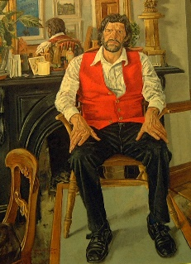

Members’ participation in the Friends’ events provides funds to the Friends Legacy Fund for future acquisitions and exhibitions for the gallery.

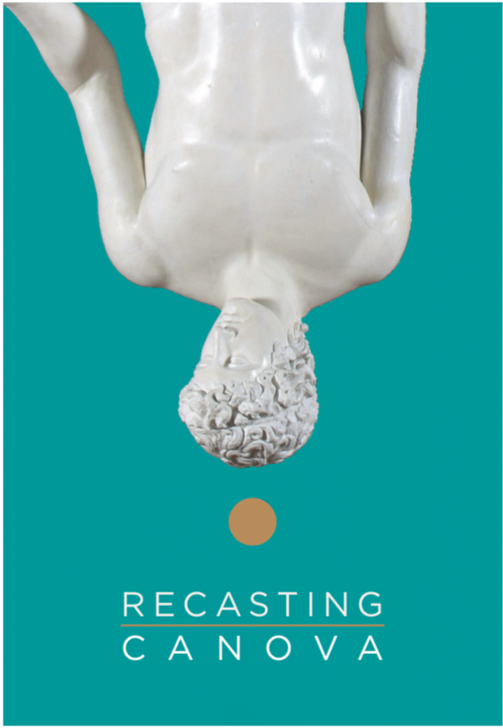

ACQUISITIONS EXAMPLES

**1991** * Vivienne Roche: Bronze sculpture

‘Viapori’ Bell commissioned by the Friends 1991

* Joseph Panzetta: Coade stone head of James Barry.

* James Scanlon: Stained glass window, Lonradh The Big Bang

**2006** * Mick O’Dea Portrait of Michael O’Siadhail

© Portrait of Michael O’Siadhail by Mick O’Dea

# 

**2009** * Print by Michael Farrell Untitled 1983

**2013** * Picasso: Maternité print

**2014**  * Miniature portrait of John Shears attributed to John Comerford (1773 - 1832) Oil on ivory, oval, 8.5cms high.

**2016** * Frederick Buck 3 miniatures (watercolour on ivory)

Francis Rowland

Elizabeth Rowland

Francis Rowland when a boy

**2017** * The publication of the book ‘Made in Cork’

The Arts and Crafts Movement 1880s -1920s

by Vera Ryan.

**2019 \*** Sponsorship of the Recasting Canova Catalogue

© Crawford Art Gallery

As an independent support group for Crawford Art Gallery, the Friends’ aim is to promote an awareness of the gallery, its collection and exhibitions and to foster an interest in all aspects of art and heritage. Through your membership and participation in the Friends’ events you provide support to the gallery through the Friends Legacy Fund for future acquisitions and exhibitions.

Be a Friend, become a Member

©James Scanlon, Lonradh, Stained glass, three panels 1993

Commissioned and presented by the Friends of Crawford Art Gallery, 1993.

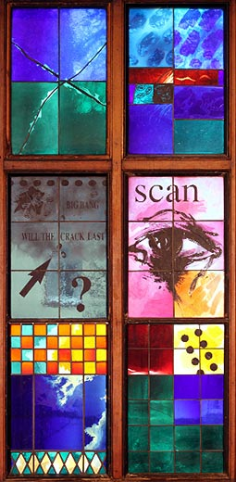

Friends of Crawford Art Gallery

an independent support group for the Crawford Art Gallery

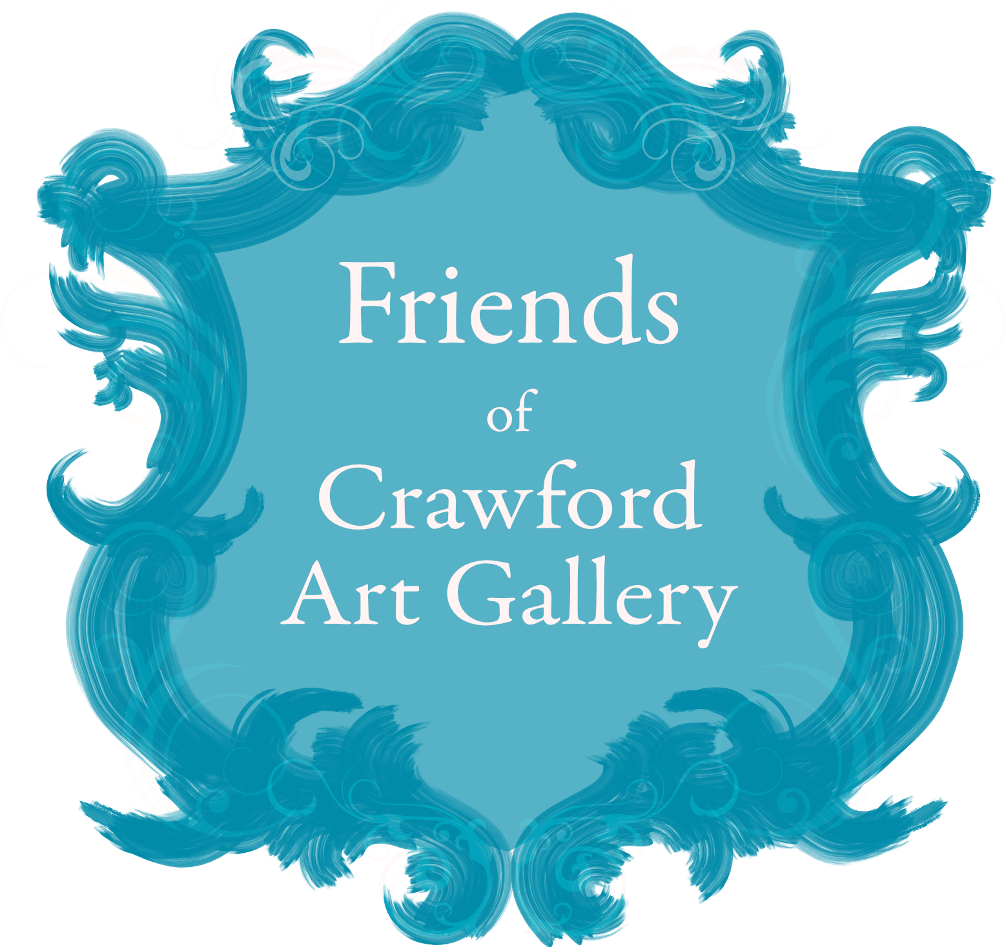

***Made in Cork***

**The Arts and Crafts Movement**

**1880s to 1920s**

*by Vera Ryan*

*Available in the Gallery Gift Shop*

This elegant book explores the importance of art and craft made in Cork during the years of the Irish Arts and Crafts movement, the 1880s to the 1920s.

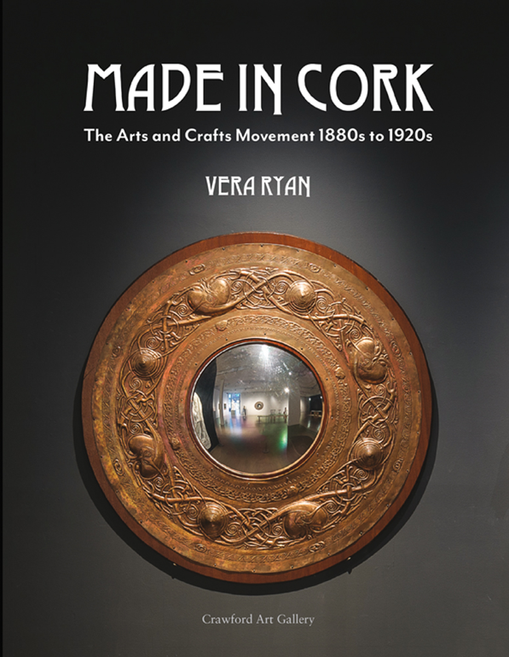

The Gift of Membership

Friends of Crawford Art Gallery Gift Membership is a unique gift packed full of surprises. Choose from our beautiful range of membership options then sit back and let us delight them throughout the year with special Members-only events and generous benefits.

To organise gift membership, first see [membership types on the form enclosed and](https://www.artgallery.nsw.gov.au/members/become-a-member/membership-types-and-prices/) choose the type that suits. Then you can arrange registration in person or post us the form and payment. We will send a gift card with the membership details enclosed on your behalf.

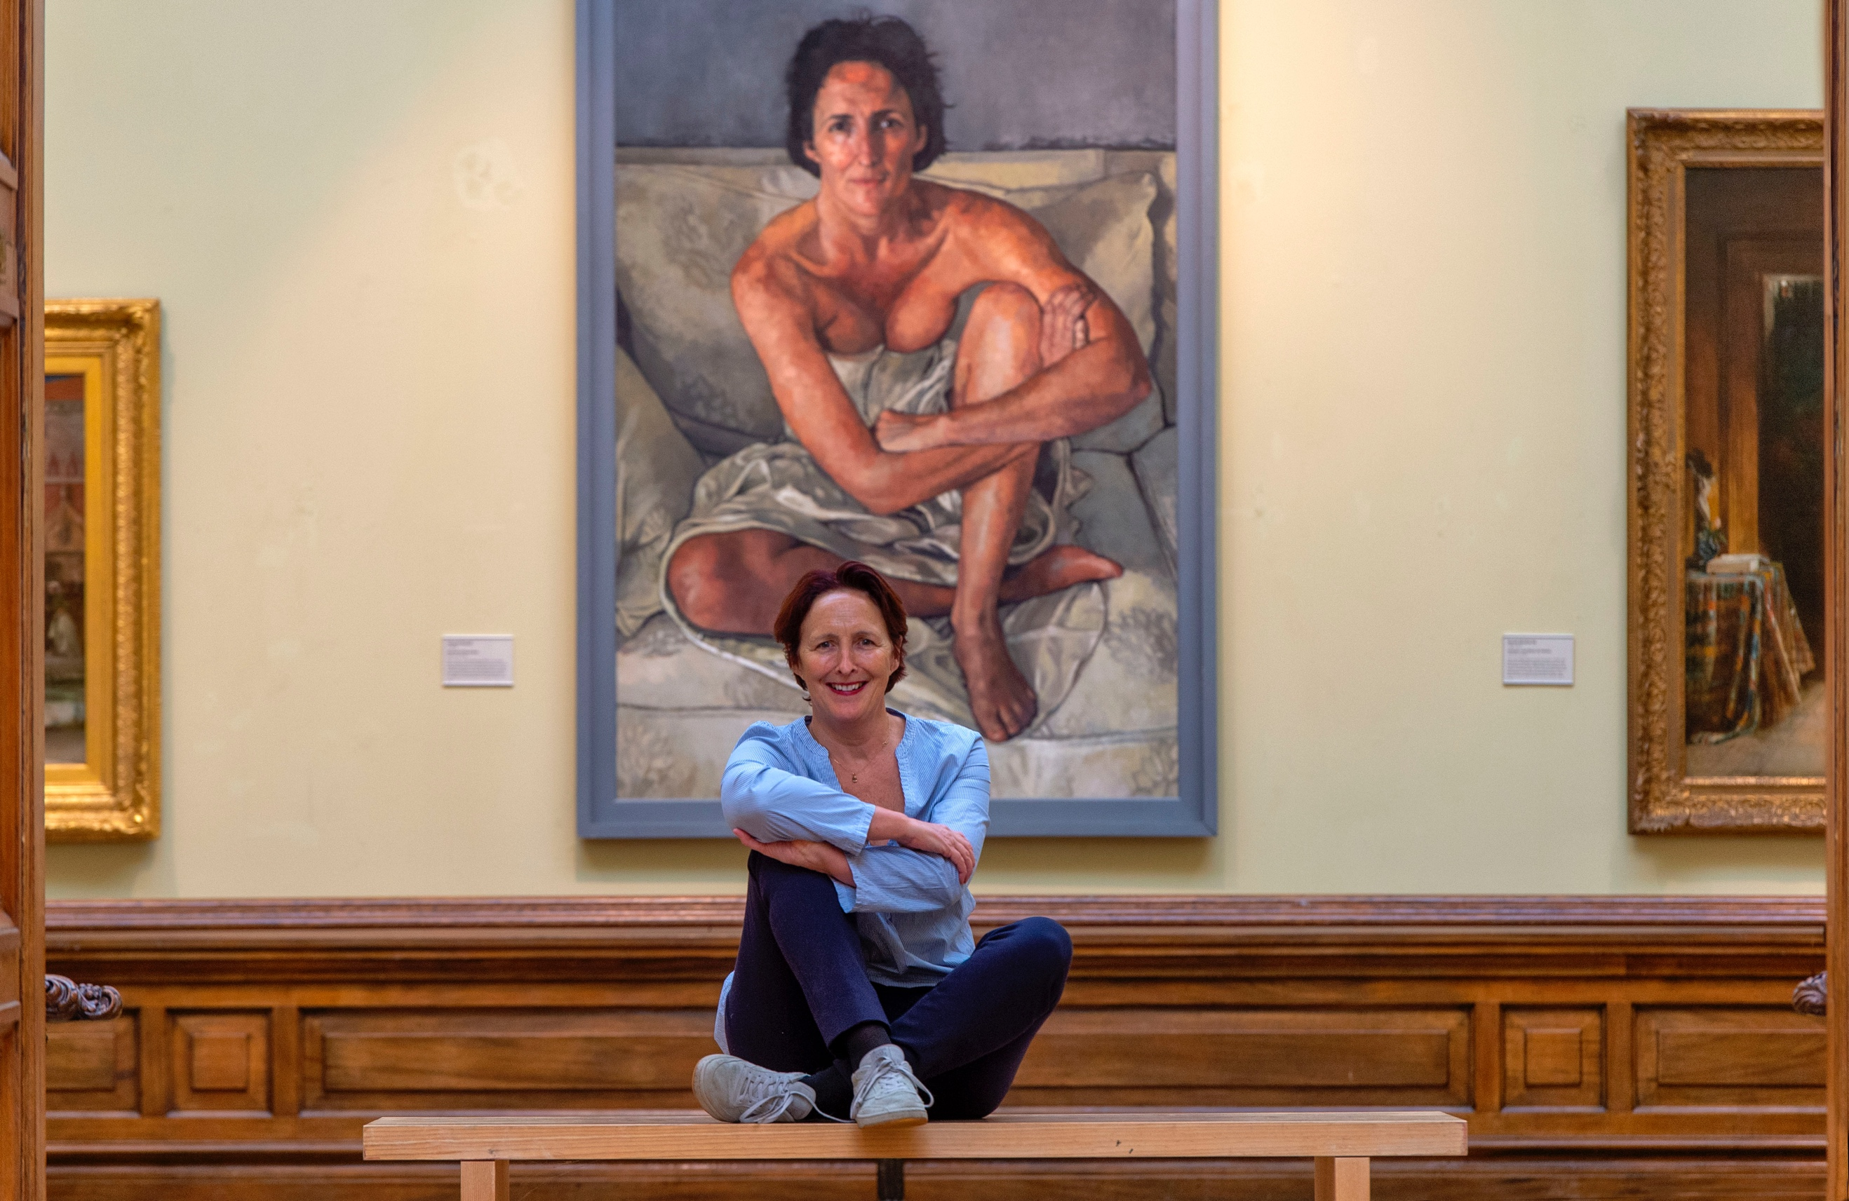

Acclaimed actor Fiona Shaw CBE gave a wonderful exclusive talk to the [Friends of the Crawford Art Gallery](https://www.facebook.com/friendsofcrawfordartgallery/?fref=mentions&__xts__%5B0%5D=68.ARCmgmgieQsFnZ6OxOOf_R1p-QqL4DGSppiRfcEitl_o2FWRUiWZMut6lxJcD7xUDqjLGbflAVio-lx3tNtuaKTaf32-JpoUej3v_FK03wwTM3XZykXTJz3UtuWr8T74dW90X6BM6eh4O9RtfSnOtNip96SIUJ4TWCm1Woz-Bzwnets_V-S8EmogaTS6qtvhrpYmc7Eedxxsb0K-taqZSI8R8aVwzGwKi219J4KuVLDX0eWCtmfeooJ0G16-B6yoHlgkYqj_mnhtPkA3H0xddJAa3XPUXNUnsC6yZshi-iBEL1HaGWwjNgQX-SYOkDWKUp7uE9Zxb8J6RnT2LNe3ayZRKw&__tn__=K-R) on Tuesday 29th January 2019 and even posed in front of her portrait, painted in 2002 by artist Victoria Russell.

**Spring & Autumn Talks Series**

**12.30 – 13.30pm.** Visit website for more details.In conjunction with the Gallery we organize lunchtime talks on Art History, Contemporary

Art and our local heritage of Art and Architecture.

**Day Trips & Private Tours**

These take place both locally and nationally throughout the year and are usually to major exhibitions (e.g. Canaletto at the National Gallery) to houses and gardens of historic interest, (e.g.Tullynally Castle, Co. Westmeath) or private artist studios. (e.g. Abbey Stained Glass Studios Dublin). Travel is by private coach and a group lunch at an attractive venue is always incorporated.

Members receive notification of and invitations to private previews and to the opening of all gallery exhibitions e.g. The Preview of Mary Swanzy ‘Voyages’ 2019.

**Exclusive In House guided tours & Talks**

Members can enjoy exclusive in-house guided tours twice a year followed by tea/coffee in the gallery library.

**Annual Cultural Trip Abroad**

Members can enjoy an annual trip abroad in the autumn. The holidays are completely guided by professionals from landing to departure with private coach throughout. They incorporate a busy schedule of visits to museums churches and historic houses and places of interest. The 2019 trip was The Delights of Northern Italy the Veneto, Venice and the Palladian Villas.

**Members Christmas Party**

Every year the Friends hold a Christmas celebration in the Gallery for all members.

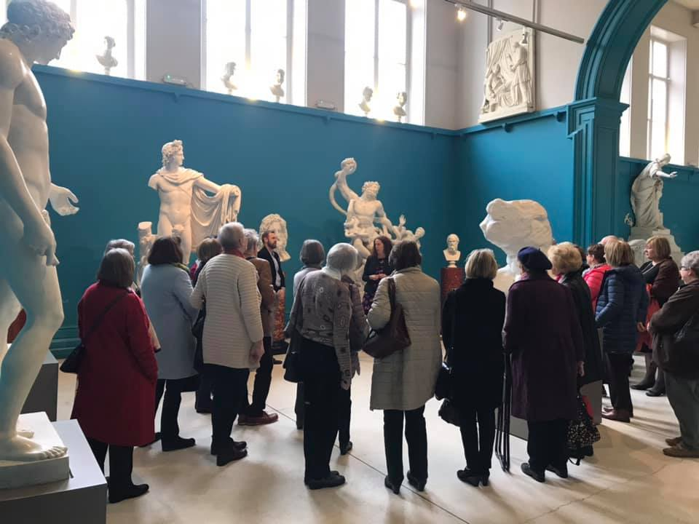

Members’ Calendar of Events



 Friends of the Crawford Art Gallery

 @friendsCAGcork

 friends@crawfordartgallery.ie

Meet the Administrators

You are welcome to visit the administrators at the gallery on

Tuesday, Wednesday and Friday between 10:00 a.m. and 14:00 p.m.

*Please request a meeting with a Friends administrator at the gift shop upon arrival.

Membership forms & Event Brochures are available on our website, via email or at the gallery.

Contact the Friends

**Post:** Friends’ Office, Crawford Art Gallery,

Emmet Place, Cork, T12 TNE6.

**Tel:** 0214907864

DATA PROTECTION

Please be reassured that all information supplied is held in confidence; it will not be shared with any third party without your express permission. All personal data will be held in accordance with the GDPR and Data Protection Acts 1988 – 2018. Friends administrators will use this data to send you email & postal (if applicable) information on events, talks, trips and tours provided by the Friends Society and the Crawford Art Gallery.

Email updates are sent via our email provider MAILCHIMP and you can unsubscribe at any time. Your personal information will be retained by the Friends for as long is necessary to administer your membership.

**Thank you for supporting The Friends of Crawford Art Gallery.**

Honorary Administrators

Annual Subscription

(Hard copy brochures & forms are available on request in the gallery)

**Membership**options are as follows

**Membership / Gift Membership runs from date subscription payment is received and can be renewed annually.**

Individual A 12Mths* €60 with Paperless / **Email only** correspondence

Individual B 12Mths* €65 with email and Postal correspondence

Couples A 12Mths* €90 with Paperless / **Email only** correspondence

Couples B 12Mths* €95 with email and Postal correspondence

**\*Please renew membership after 12mths to continue receiving correspondence.**

Life membership Annual subscription Fee x 10

**Please print & complete the form provided and forward payment.**

**By Cash / Cheque:** (Cheques payable to: Friends of Crawford Art Gallery)

**By Post:**

Friends’ Office, Crawford Art Gallery, Emmet Place, Cork, Ireland, T12 TNE6

**By Standing Order/ Direct Debt:** Contact the Friends office for details.

**By Bank Transfer:** BIC: AIBKIE2D IBAN: IE87 AIBK 9341 4306 8531 11

**NB:** Due to the new GDPR regulations, if a member chooses not to renew their membership, the Friends administrators will be legally obliged to remove their personal details from the database.

Therefore no postal / email correspondence will be forwarded from the members’ renewal date.